UNITED STATES
SECURITIES AND EXCHANGE COMMISSION
WASHINGTON, D.C. 20549

FORM 8-K

CURRENT REPORT

Pursuant to Section 13 or 15(d) of the Securities Exchange Act of 1934

Date of Report (Date of earliest event reported): August 13, 2026

Chicago Atlantic BDC, Inc.
(Exact name of Registrant as Specified in Its Charter)

Maryland |  | 001-40564 |  | 86-2872887
(State or Other Jurisdiction  of Incorporation) |  | (Commission File Number) |  | (IRS Employer  Identification No.)

600 Madison Avenue, Suite 1800 New York, New York |  | 10022
(Address of Principal Executive Offices) |  | (Zip Code)

Registrant’s Telephone Number, Including Area Code: 312 625-9295

Not Applicable
(Former Name or Former Address, if Changed Since Last Report)

Check the appropriate box below if the Form 8-K filing is intended to simultaneously satisfy the filing obligation of the registrant under any of the following provisions:

☒ | Written communications pursuant to Rule 425 under the Securities Act (17 CFR 230.425)

☒ | Soliciting material pursuant to Rule 14a-12 under the Exchange Act (17 CFR 240.14a-12)

☐ | Pre-commencement communications pursuant to Rule 14d-2(b) under the Exchange Act (17 CFR 240.14d-2(b))

☐ | Pre-commencement communications pursuant to Rule 13e-4(c) under the Exchange Act (17 CFR 240.13e-4(c))

Securities registered pursuant to Section 12(b) of the Act:

Title of each class |  | Trading Symbol(s) |  | Name of each exchange on which registered
Common Stock, $0.01 par value per share |  | LIEN |  | The Nasdaq Stock Market LLC

Indicate by check mark whether the registrant is an emerging growth company as defined in Rule 405 of the Securities Act of 1933 (§ 230.405 of this chapter) or Rule 12b-2 of the Securities Exchange Act of 1934 (§ 240.12b-2 of this chapter).

Emerging growth company ☒

If an emerging growth company, indicate by check mark if the registrant has elected not to use the extended transition period for complying with any new or revised financial accounting standards provided pursuant to Section 13(a) of the Exchange Act. ☐

Item 2.02 Results of Operations and Financial Condition.

On August 13, 2026, Chicago Atlantic BDC, Inc. (the “Company”) issued a press release announcing its financial results for the second quarter ended June 30, 2026. The press release is attached as Exhibit 99.1 to this Current Report on Form 8-K and is incorporated herein by reference.

The information in Item 2.02 of this Current Report on Form 8-K, including Exhibit 99.1 furnished herewith, is being furnished and shall not be deemed “filed” for any purpose of Section 18 of the Securities Exchange Act of 1934, as amended (the “Exchange Act”), or otherwise subject to the liabilities of such section. The information in Item 2.02 of this Current Report on Form 8-K shall not be deemed to be incorporated by reference into any filing under the Securities Act of 1933, as amended (the “Securities Act”), or the Exchange Act, except as shall be expressly set forth by specific reference in such filing.

Item 7.01 Regulation FD Disclosure.

On August 13, 2026, the Company disseminated an earnings presentation to be used in connection with its conference call and live webcast on August 13, 2026 at 9:00 a.m. Eastern time to discuss its financial results for the second quarter ended June 30, 2026. The earnings presentation is attached as Exhibit 99.2 to this Current Report on Form 8-K and is incorporated herein by reference.

The information in Item 7.01 of this Current Report on Form 8-K, including Exhibit 99.2 furnished herewith, is being furnished and shall not be deemed “filed” for any purpose of Section 18 of the Exchange Act, or otherwise subject to the liabilities of such section. The information in Item 7.01 of this Current Report on Form 8-K shall not be deemed to be incorporated by reference into any filing under the Securities Act or the Exchange Act, except as shall be expressly set forth by specific reference in such filing.

No Offer or Solicitation

This communication is not intended to and shall not constitute an offer to sell or the solicitation of an offer to sell or the solicitation of an offer to buy any securities, or a solicitation of any vote or approval, nor shall there be any sale of securities in any jurisdiction in which such offer, solicitation or sale would be unlawful prior to registration or qualification under the securities laws of any such jurisdiction. No offer of securities shall be made except by means of a prospectus meeting the requirements of Section 10 of the Securities Act.

Additional Information and Where to Find It

This communication includes information relating to the proposed merger (the “Merger”) of Chicago Atlantic Real Estate Finance, Inc. (“REFI”) with and into the Company, along with related proposals for which stockholder approval will be sought, pursuant to the Agreement and Plan of Merger, dated as of June 17, 2026 (the “Merger Agreement”) by and between REFI and the Company. The Merger Agreement was unanimously approved by the Boards of Directors of both REFI and the Company, each acting on the unanimous recommendation of its special committee of independent directors. In connection with the proposals, the Company filed with the U.S. Securities and Exchange Commission (“SEC”) a registration statement on Form N-14 on July 31, 2026, which includes a joint proxy statement of REFI and the Company and a prospectus of the Company (the “Proxy Statement/Prospectus”). This communication does not constitute an offer to sell or the solicitation of an offer to buy any securities or a solicitation of any vote or approval. No offer of securities shall be made except by means of a prospectus meeting the requirements of Section 10 of the Securities Act. STOCKHOLDERS OF REFI AND THE COMPANY ARE URGED TO READ THE PROXY STATEMENT/PROSPECTUS, AND OTHER DOCUMENTS THAT ARE FILED OR WILL BE FILED WITH THE SEC, AS WELL AS ANY AMENDMENTS OR SUPPLEMENTS TO THESE DOCUMENTS, CAREFULLY AND IN THEIR ENTIRETY WHEN THEY BECOME AVAILABLE BECAUSE THEY WILL CONTAIN IMPORTANT INFORMATION ABOUT REFI, THE COMPANY, THE MERGER AND THE PROPOSALS. Investors and security holders will be able to obtain the documents filed with the SEC free of charge at the SEC’s website, www.sec.gov, or from each company’s investor relations website at www.investors.chicagoatlanticbdc.com (the Company) and www.investors.refi.reit (REFI), or by directing a request to LIEN@chicagoatlantic.com (the Company) or IR@REFI.reit (REFI).

1

Participants in the Solicitation

REFI, the Company and their respective directors and executive officers, Chicago Atlantic BDC Advisers, LLC, the external investment adviser to the Company (the “LIEN Adviser”), and Chicago Atlantic REIT Manager, LLC, the external manager of REFI (the “REFI Manager”), and their respective directors, officers, members, managers, partners, employees and affiliates, and other persons may be deemed to be participants in the solicitation of proxies from the stockholders of REFI and the Company in connection with the Merger and the related proposals. Information regarding the persons who may, under the rules of the SEC, be deemed participants in the solicitation of the stockholders of REFI and the Company in connection with the Merger and the related proposals, including a description of their direct or indirect interests, by security holdings or otherwise, will be included in the Proxy Statement/Prospectus and other relevant materials to be filed with the SEC when they become available. Additional information regarding the ownership of the securities of REFI and the Company by their respective directors and executive officers is included in their SEC filings on Forms 3, 4 and 5, which can be found through the SEC’s website at www.sec.gov. Information about the directors and executive officers of the Company is set forth in the Company’s proxy statement for its 2026 annual meeting of stockholders, filed with the SEC on April 30, 2026, and in the Company’s Annual Report on Form 10-K for the fiscal year ended December 31, 2025, filed with the SEC on March 19, 2026. Information about the directors and executive officers of REFI is set forth in REFI’s proxy statement for its 2026 annual meeting of stockholders, filed with the SEC on April 23, 2026, and in REFI’s Annual Report on Form 10-K for the fiscal year ended December 31, 2025, filed with the SEC on March 12, 2026. Each of these documents is available free of charge at the SEC’s website, www.sec.gov, or from REFI’s or the Company’s investor relations website, as applicable.

Item 9.01 Financial Statements and Exhibits.

d) Exhibits

Exhibit  Number |  | Description
99.1 |  | Press release, dated August 13, 2026.
99.2 |  | Earnings Presentation, dated August 13, 2026.
104 |  | Cover Page Interactive Data File (embedded within the Inline XBRL document)

2

SIGNATURES

Pursuant to the requirements of the Securities Exchange Act of 1934, the registrant has duly caused this report to be signed on its behalf by the undersigned hereunto duly authorized.

 | CHICAGO ATLANTIC BDC, INC.
Date: August 13, 2026 | By: | /s/ Thomas Geoffroy
 |  | Interim Chief Financial Officer

3

Exhibit 99.1



Chicago Atlantic BDC, Inc. Reports Second Quarter 2026 Financial Results

NEW YORK, August 13, 2026 — Chicago Atlantic BDC, Inc. (“LIEN” or the “Company”) (NASDAQ: LIEN), a specialty finance company that has elected to be regulated as a business development company, today announced its financial results for the second quarter ended June 30, 2026.

Operating Highlights

 |  | For the Three Months Ended
 |  | June 30,  2026 |  |  |  |  |  |  |  | March 31,  2026
(Dollar amounts in millions, except per share data)* |  | Total Amount |  |  |  | Per Share |  |  |  | Total Amount |  |  |  | Per Share
Total investment income |  | $ | 14.0 |  |  | $ | 0.61 |  |  | $ | 16.7 |  |  | $ | 0.73
Net investment income |  | $ | 7.7 |  |  | $ | 0.34 |  |  | $ | 10.0 |  |  | $ | 0.44
Net change in unrealized gains (losses) |  | $ | (1.6 | ) |  | $ | (0.07 | ) |  | $ | (1.4 | ) |  | $ | (0.06 | )
Net increase in net assets resulting from operations |  | $ | 6.1 |  |  | $ | 0.27 |  |  | $ | 8.5 |  |  | $ | 0.37

* | totals may not foot due to rounding

Peter Sack, Chief Executive Officer of the Company, commented, “The second quarter reflected the continued strength of our portfolio and disciplined underwriting approach. The decline in portfolio fair value was driven primarily by repayments and amortization activity rather than credit deterioration or valuation markdowns. With no investments on non-accrual status, steady portfolio risk ratings, and a 100% senior secured debt portfolio generating a weighted average yield on debt investments of 16.0%, we remain positioned to generate attractive risk-adjusted returns.”

Mr. Sack continued, “We ended the quarter with $73.9 million in available liquidity and a pipeline of approximately $1.1 billion. Several anticipated fundings shifted into the third quarter due to transaction timing, and we continue to see strong borrower demand and a healthy pipeline of opportunities, giving us confidence in our deployment outlook.”

Balance Sheet Highlights

 |  | As of
(Dollar amounts in millions, except per share data) |  | June 30,  2026 |  |  |  | March 31,  2026
Total assets |  | $ | 344.0 |  |  | $ | 373.1
Total net assets |  | $ | 302.5 |  |  | $ | 304.2
Net asset value per share |  | $ | 13.26 |  |  | $ | 13.33
Outstanding borrowings |  | $ | 27.0 |  |  | $ | 54.5
Debt-to-equity ratio |  |  | 0.09x |  |  |  | 0.18x

Portfolio Activity

 |  | For the Three Months Ended
(Dollar amounts in millions) |  | June 30,  2026 |  |  |  | March 31,  2026
Investment fundings (portfolio companies / principal) |  |  | 1 / $2.7 |  |  |  | 7 / $93.9
Repayments / amortization / refinancing |  |  | $26.7 / $5.5 / $0.0 |  |  |  | $13.7 / $7.6 / $42.1
Portfolio Information:
Total investment portfolio at fair value |  |  | $334.8 |  |  |  | $364.0
Number of portfolio companies |  |  | 37 |  |  |  | 40
Weighted average yield on debt investments |  |  | 16.0% |  |  |  | 15.8%
Loans on non-accrual status (% of portfolio at fair value) |  |  | 0.0% |  |  |  | 0.0%

As of June 30, 2026, the Company’s investment portfolio had an aggregate fair value of approximately $334.8 million across 37 portfolio companies. During the quarter ended June 30, 2026, the Company funded one new debt investment to an existing portfolio company with an aggregate value of $2.7 million. Three positions were repaid in full during the quarter ended June 30, 2026, representing $26.7 million. The Company also received scheduled and unscheduled amortization payments totaling $5.5 million.

Subsequent to quarter end, one position of $25.0 million was funded to a new portfolio company. As of June 30, 2026, there were no loans on non-accrual status.

Liquidity and Capital Resources

As of June 30, 2026, the Company had $73.9 million of liquidity, including $0.9 million of cash and $73.0 million of borrowings available to be drawn on its $100.0 million senior credit facility, which is subject to certain borrowing base requirements and other restrictions. As of August 12, 2026, the Company had $53.5 million outstanding on its senior credit facility and approximately $47.2 million of liquidity.

On May 11, 2026, the Company filed a shelf registration statement with the Securities and Exchange Commission (the “SEC”), which once declared effective, will allow the Company to issue up to $500 million of securities, including debt securities. The shelf registration is intended to provide the Company with enhanced financial flexibility to efficiently access the capital markets to grow the Company’s portfolio.

Dividend

On August 10, 2026, the Company’s Board of Directors declared a third quarter 2026 dividend of $0.34 per share, payable on October 9, 2026, with a record date of September 25, 2026, for a total of approximately $7.8 million. The second quarter 2026 dividend of $0.34 per share was paid on July 10, 2026, to shareholders of record as of June 26, 2026, and was the seventh consecutive dividend at that rate.

Recent Developments

On June 17, 2026, the Company entered into an Agreement and Plan of Merger (the “Merger Agreement”) with Chicago Atlantic Real Estate Finance, Inc. (“REFI”) (NASDAQ: REFI), an affiliated company that has elected to be taxed as a real estate investment trust and is externally managed by an affiliate of the Company’s investment adviser, pursuant to which REFI will merge with and into the Company, with the Company continuing as the surviving company (the “Merger”). Prior to the Merger, REFI will elect to be regulated as a business development company under the Investment Company Act of 1940, as amended (the “1940 Act”). At closing, REFI’s stockholders will receive a number of shares of the Company’s common stock determined based on the ratio (the “Exchange Ratio”) of REFI’s net asset value (“NAV”) per share, as adjusted in accordance with the Merger Agreement, to the Company’s NAV per share, similarly adjusted, in each case as determined shortly prior to closing. Based on the respective NAVs of REFI and the Company as of March 31, 2026, and without giving effect to any other changes in the inputs to the Exchange Ratio occurring after March 31, 2026, former REFI stockholders would be expected to own approximately 50.5% of the Company immediately following the Merger. The actual pro forma ownership percentage will depend on the Exchange Ratio calculated shortly prior to closing and may differ from the March 31, 2026 estimate. Completion of the Merger is subject to the approval of stockholders of both the Company and REFI, including approval by REFI’s stockholders of REFI’s election to be regulated as a business development company under the 1940 Act and approval by REFI’s stockholders of an investment advisory agreement, as well as regulatory approvals, third-party consents and other customary closing conditions. Assuming these conditions are satisfied, the Merger is expected to close in the fourth quarter of 2026. There can be no assurance that the Merger will be completed on the anticipated terms or timing, or at all. Additional information regarding the Merger is set forth below under “Additional Information and Where to Find It.”

2

Live Conference Call and Webcast

The Company will host a conference call and live audio webcast, both open for the general public to hear, to discuss the Company’s second quarter 2026 financial results at 9:00 a.m. ET on Thursday, August 13, 2026. The number to access the conference call is 833-630-1956 (international callers: 412-317-1837). The live audio webcast of the call will also be available at the following link https://edge.media-server.com/mmc/p/a3rmvk74.

A replay of the call will be available at investors.chicagoatlanticbdc.com by the end of day on August 13, 2026.

About Chicago Atlantic BDC, Inc.

The Company is a specialty finance company that has elected to be regulated as a business development company under the 1940 Act, as amended, and has elected to be treated as a regulated investment company for U.S. federal income tax purposes. The Company’s investment objective is to maximize risk-adjusted returns on equity for its stockholders by investing primarily in direct loans to privately held middle-market companies, with a primary focus on cannabis companies. The Company is managed by Chicago Atlantic BDC Advisers, LLC (the “Adviser”), an investment manager focused on the cannabis industry and other niche or underfollowed sectors. For more information, please visit chicagoatlanticbdc.com.

Forward-Looking Statements

This release contains forward-looking statements within the meaning of the Private Securities Litigation Reform Act of 1995 that reflect the Company’s current views and projections with respect to, among other things, future events and financial performance, including statements regarding the proposed Merger with REFI and its expected timing and effects, the expected pro forma ownership of former REFI stockholders in LIEN following the Merger, the expected implementation and effects of federal rescheduling of medical cannabis, the Company’s dividend expectations, and the Company’s future operations and strategies. Words such as “believes,” “expects,” “will,” “intends,” “plans,” “guidance,” “estimates,” “projects,” “anticipates,” “future” and similar expressions are intended to identify forward-looking statements. These statements are not guarantees of future performance and are subject to numerous risks and uncertainties, including, without limitation: (i) the risk that the proposed Merger may not be completed on the anticipated terms or timing, or at all; (ii) the failure to obtain the required stockholder approvals of REFI or LIEN, including approval of REFI’s election to be regulated as a business development company and approval of REFI’s investment advisory agreement; (iii) the failure to satisfy other conditions to closing, including regulatory approvals and third-party consents; (iv) the effect of the announcement or pendency of the Merger on the Company’s business, operating results, and relationships with borrowers, employees and other counterparties; (v) risks that the Merger may divert management’s attention from the Company’s ongoing business; (vi) the outcome of any legal proceedings that may be instituted against REFI or LIEN related to the Merger; (vii) the amount of costs, fees and expenses related to the Merger; (viii) developments in the cannabis industry, including federal, state and local legal and regulatory changes and the implementation of federal rescheduling; (ix) changes in interest rates, credit spreads and macroeconomic conditions; and (x) the other risks identified in the Company’s filings with the SEC, including its Annual Report on Form 10-K for the year ended December 31, 2025 and subsequent Quarterly Reports on Form 10-Q, and in the registration statement on Form N-14 filed by LIEN with the SEC on July 31, 2026, including the joint proxy statement/prospectus contained therein. New risks and uncertainties arise over time, and it is not possible to predict those events or how they may affect us. We do not undertake any obligation to publicly update or revise any forward-looking statements, whether as a result of new information, future events or otherwise, except as required by law.

No Offer or Solicitation

This press release is not intended to and shall not constitute an offer to sell or the solicitation of an offer to sell or the solicitation of an offer to buy any securities, or a solicitation of any vote or approval, nor shall there be any sale of securities in any jurisdiction in which such offer, solicitation or sale would be unlawful prior to registration or qualification under the securities laws of any such jurisdiction. No offer of securities shall be made except by means of a prospectus meeting the requirements of Section 10 of the Securities Act of 1933, as amended (the “Securities Act”), or in a transaction exempt from the registration requirements of the Securities Act.

3

Additional Information and Where to Find It

This communication includes information relating to the Merger of REFI with and into the Company, along with related proposals for which stockholder approval will be sought, pursuant to the Merger Agreement. The Merger Agreement was unanimously approved by the Boards of Directors of both the Company and REFI, each acting on the unanimous recommendation of its special committee of independent directors (each, a “Special Committee”). In connection with the proposals, on July 31, 2026, the Company filed relevant materials with the SEC, including a registration statement on Form N-14, which has not yet been declared effective, which includes a joint proxy statement of the Company and REFI and a prospectus of the Company (the “Proxy Statement/Prospectus”). This communication does not constitute an offer to sell or the solicitation of an offer to buy any securities or a solicitation of any vote or approval. No offer of securities shall be made except by means of a prospectus meeting the requirements of Section 10 of the Securities Act. STOCKHOLDERS OF THE COMPANY AND REFI ARE URGED TO READ THE PROXY STATEMENT/PROSPECTUS, AND OTHER DOCUMENTS THAT ARE FILED OR WILL BE FILED WITH THE SEC, AS WELL AS ANY AMENDMENTS OR SUPPLEMENTS TO THESE DOCUMENTS, CAREFULLY AND IN THEIR ENTIRETY WHEN THEY BECOME AVAILABLE BECAUSE THEY WILL CONTAIN IMPORTANT INFORMATION ABOUT THE COMPANY, REFI, THE MERGER AND THE PROPOSALS. Investors and security holders will be able to obtain the documents filed with the SEC free of charge at the SEC’s website, www.sec.gov, or from each company’s investor relations website at www.investors.chicagoatlanticbdc.com (the Company) and www.investors.refi.reit (REFI), or by directing a request to LIEN@chicagoatlantic.com (the Company) or IR@REFI.reit (REFI).

Participants in the Solicitation

The Company, REFI, the Adviser, Chicago Atlantic REIT Manager, LLC, the external manager of REFI, and their respective directors, officers, members, managers, partners, employees and affiliates, and other persons may be deemed to be participants in the solicitation of proxies from the stockholders of the Company and REFI in connection with the Merger and the related proposals. Information regarding the persons who may, under the rules of the SEC, be deemed participants in the solicitation of the stockholders of the Company and REFI in connection with the Merger and the related proposals, including a description of their direct or indirect interests, by security holdings or otherwise, will be included in the Proxy Statement/Prospectus and other relevant materials to be filed with the SEC when they become available. Additional information regarding the ownership of securities of the Company and REFI by their respective directors and executive officers is included in their SEC filings on Forms 3, 4 and 5, which can be found through the SEC’s website at www.sec.gov. Information about the directors and executive officers of the Company is set forth in the Company’s proxy statement for its 2026 annual meeting of stockholders, filed with the SEC on April 30, 2026, and in LIEN’s Annual Report on Form 10-K for the fiscal year ended December 31, 2025, filed with the SEC on March 19, 2026. Information about the directors and executive officers of REFI is set forth in REFI’s proxy statement for its 2026 annual meeting of stockholders, filed with the SEC on April 23, 2026, and in REFI’s Annual Report on Form 10-K for the fiscal year ended December 31, 2025, filed with the SEC on March 12, 2026. Each of these documents is available free of charge at the SEC’s website, www.sec.gov, or from the Company’s or REFI’s investor relations website, as applicable.

Contact

Tripp Sullivan
Lisa Kampf
SCR Partners
LIEN@chicagoatlantic.com

4

CHICAGO ATLANTIC BDC, INC.
Statements of Assets and Liabilities

 |  | June 30,  2026 |  |  |  | March 31,  2026
 |  | (Unaudited) |  |  |  | (Unaudited)
ASSETS
Investments at fair value:
Non-controlled/non-affiliate investments |  | $ | 334,833,992 |  |  | $ | 346,596,232
Non-controlled affiliate investments |  |  | - |  |  |  | 17,370,481
Total investments at fair value (amortized cost of $336,747,389 and $364,290,996, respectively) |  |  | 334,833,992 |  |  |  | 363,966,713
Interest receivable |  |  | 3,588,157 |  |  |  | 4,358,743
Prepaid expenses and other assets |  |  | 2,605,281 |  |  |  | 1,305,750
Due from affiliates |  |  | 2,008,432 |  |  |  | 152,958
Cash |  |  | 925,534 |  |  |  | 3,346,316
Total assets |  | $ | 343,961,396 |  |  | $ | 373,130,480
LIABILITIES
Revolving line of credit |  | $ | 27,000,000 |  |  | $ | 54,500,000
Distributions payable |  |  | 7,759,001 |  |  |  | 7,759,001
Income-based incentive fees payable |  |  | 1,920,905 |  |  |  | 2,457,290
Other payables |  |  | 1,677,560 |  |  |  | 876,266
Management fee payable |  |  | 1,555,022 |  |  |  | 1,529,360
Due to affiliates |  |  | 1,441,236 |  |  |  | 1,359,256
Professional fees payable |  |  | 118,133 |  |  |  | 464,846
Total liabilities |  | $ | 41,471,857 |  |  | $ | 68,946,019
NET ASSETS
Common stock, $0.01 par value, 100,000,000 shares authorized, 22,820,590 and 22,820,590 shares issued and outstanding, respectively |  | $ | 228,206 |  |  | $ | 228,206
Additional paid-in-capital |  |  | 303,079,082 |  |  |  | 303,079,082
Distributable earnings |  |  | (817,749 | ) |  |  | 877,173
Total net assets |  | $ | 302,489,539 |  |  | $ | 304,184,461
NET ASSET VALUE PER SHARE |  | $ | 13.26 |  |  | $ | 13.33

5

CHICAGO ATLANTIC BDC, INC.
Statements of Operations

 |  | For the Three Months Ended
 |  | June 30,  2026 |  |  |  | March 31,  2026
INVESTMENT INCOME
Non-controlled/non-affiliate investment income
Interest income |  | $ | 12,333,209 |  |  | $ | 13,780,772
Fee income |  |  | 659,411 |  |  |  | 2,096,857
Total investment income from non-controlled/non-affiliate investments |  |  | 12,992,620 |  |  |  | 15,877,629
Non-controlled affiliate investment income
Interest income |  |  | 955,512 |  |  |  | 802,644
Fee income |  |  | 22,500 |  |  |  | 22,500
Total investment income from non-controlled affiliate investments |  |  | 978,012 |  |  |  | 825,144
Total investment income |  |  | 13,970,632 |  |  |  | 16,702,773
EXPENSES
Income-based incentive fees |  |  | 1,920,903 |  |  |  | 2,457,289
Management fee |  |  | 1,555,022 |  |  |  | 1,529,359
General and administrative expenses |  |  | 1,142,752 |  |  |  | 1,212,784
Interest expense |  |  | 1,000,939 |  |  |  | 1,024,542
Professional fees |  |  | 210,244 |  |  |  | 198,238
Audit expense |  |  | 153,750 |  |  |  | 153,750
Other expenses |  |  | 145,109 |  |  |  | 146,106
Sub-administrator fees |  |  | 115,766 |  |  |  | 133,410
Legal expenses |  |  | 72,954 |  |  |  | 45,750
Excise tax expense |  |  | - |  |  |  | 2,730
Capital gains incentive fees |  |  | - |  |  |  | (163,473 | )
Total expenses |  |  | 6,317,439 |  |  |  | 6,740,485
NET INVESTMENT INCOME (LOSS) |  |  | 7,653,193 |  |  |  | 9,962,288
NET CHANGE IN UNREALIZED APPRECIATION (DEPRECIATION) ON INVESTMENTS
Non-controlled non-affiliate investments |  |  | (528,944 | ) |  |  | (2,487,070 | )
Non-controlled affiliate investments |  |  | (1,060,170 | ) |  |  | 1,060,170
Net change in unrealized appreciation (depreciation) on investments |  |  | (1,589,114 | ) |  |  | (1,426,900 | )
Net realized and unrealized gains (losses) |  |  | (1,589,114 | ) |  |  | (1,426,900 | )
NET INCREASE (DECREASE) IN NET ASSETS RESULTING FROM OPERATIONS |  | $ | 6,064,079 |  |  | $ | 8,535,388
NET INVESTMENT INCOME (LOSS) PER SHARE - BASIC AND DILUTED |  | $ | 0.34 |  |  | $ | 0.44
NET INCREASE (DECREASE) IN NET ASSETS RESULTING FROM OPERATIONS PER SHARE - BASIC AND DILUTED |  | $ | 0.27 |  |  | $ | 0.37
WEIGHTED AVERAGE SHARES OUTSTANDING - BASIC AND DILUTED |  |  | 22,820,590 |  |  |  | 22,820,590

6

Exhibit 99.2

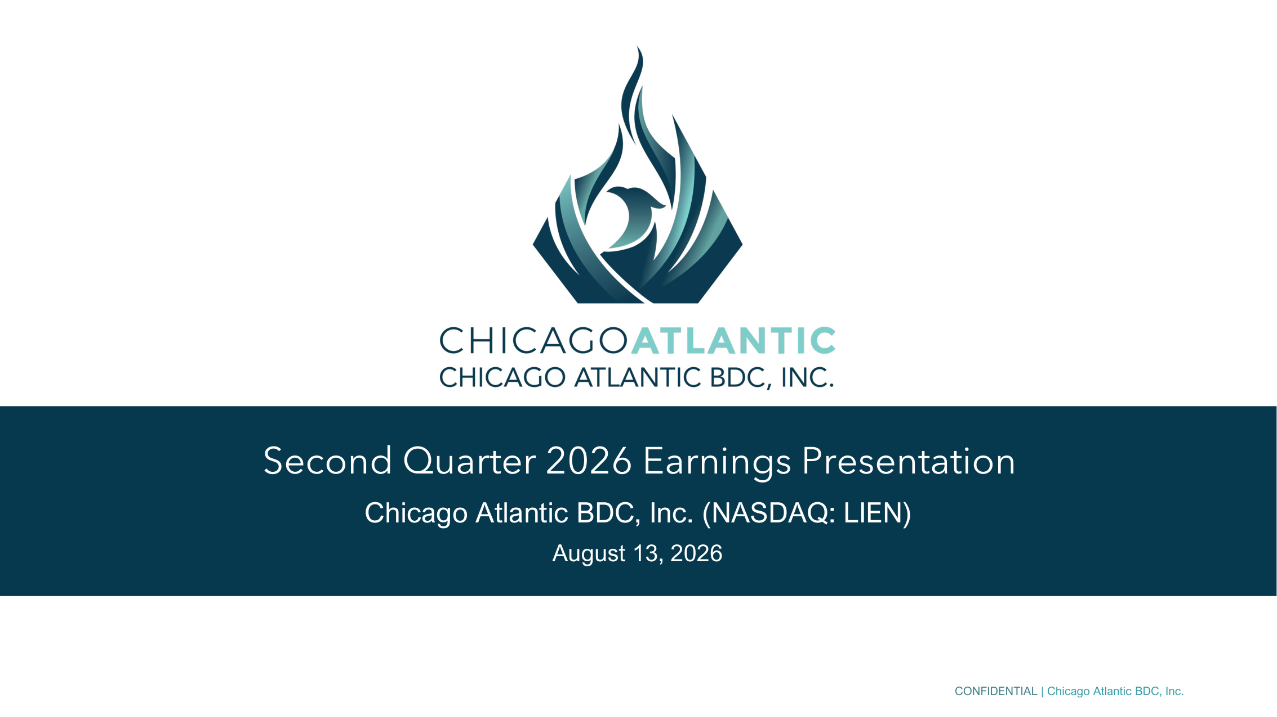
CONFIDENTIAL | Chicago Atlantic BDC, Inc. Second Quarter 2026 Earnings Presentation Chicago Atlantic BDC, Inc. (NASDAQ: LIEN) August 13, 2026

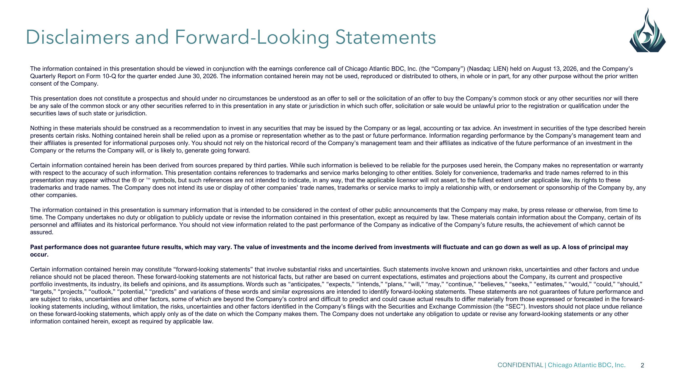
CONFIDENTIAL | Chicago Atlantic BDC, Inc. 2 The information contained in this presentation should be viewed in conjunction with the earnings conference call of Chicago Atlantic BDC, Inc. (the "Company") (Nasdaq: LIEN) held on August 13, 2026, and the Company's Quarterly Report on Form 10-Q for the quarter ended June 30, 2026. The information contained herein may not be used, reproduced or distributed to others, in whole or in part, for any other purpose without the prior written consent of the Company. This presentation does not constitute a prospectus and should under no circumstances be understood as an offer to sell or the solicitation of an offer to buy the Company's common stock or any other securities nor will there be any sale of the common stock or any other securities referred to in this presentation in any state or jurisdiction in which such offer, solicitation or sale would be unlawful prior to the registration or qualification under the securities laws of such state or jurisdiction. Nothing in these materials should be construed as a recommendation to invest in any securities that may be issued by the Company or as legal, accounting or tax advice. An investment in securities of the type described herein presents certain risks. Nothing contained herein shall be relied upon as a promise or representation whether as to the past or future performance. Information regarding performance by the Company's management team and their affiliates is presented for informational purposes only. You should not rely on the historical record of the Company's management team and their affiliates as indicative of the future performance of an investment in the Company or the returns the Company will, or is likely to, generate going forward. Certain information contained herein has been derived from sources prepared by third parties. While such information is believed to be reliable for the purposes used herein, the Company makes no representation or warranty with respect to the accuracy of such information. This presentation contains references to trademarks and service marks belonging to other entities. Solely for convenience, trademarks and trade names referred to in this presentation may appear without the ® or symbols, but such references are not intended to indicate, in any way, that the applicable licensor will not assert, to the fullest extent under applicable law, its rights to these trademarks and trade names. The Company does not intend its use or display of other companies' trade names, trademarks or service marks to imply a relationship with, or endorsement or sponsorship of the Company by, any other companies. The information contained in this presentation is summary information that is intended to be considered in the context of other public announcements that the Company may make, by press release or otherwise, from time to time. The Company undertakes no duty or obligation to publicly update or revise the information contained in this presentation, except as required by law. These materials contain information about the Company, certain of its personnel and affiliates and its historical performance. You should not view information related to the past performance of the Company as indicative of the Company's future results, the achievement of which cannot be assured. Past performance does not guarantee future results, which may vary. The value of investments and the income derived from investments will fluctuate and can go down as well as up. A loss of principal may occur. Certain information contained herein may constitute "forward-looking statements" that involve substantial risks and uncertainties. Such statements involve known and unknown risks, uncertainties and other factors and undue reliance should not be placed thereon. These forward-looking statements are not historical facts, but rather are based on current expectations, estimates and projections about the Company, its current and prospective portfolio investments, its industry, its beliefs and opinions, and its assumptions. Words such as "anticipates," "expects," "intends," "plans," "will," "may," "continue," "believes," "seeks," "estimates," "would," "could," "should," "targets," "projects," "outlook," "potential," "predicts" and variations of these words and similar expressions are intended to identify forward-looking statements. These statements are not guarantees of future performance and are subject to risks, uncertainties and other factors, some of which are beyond the Company's control and difficult to predict and could cause actual results to differ materially from those expressed or forecasted in the forward- looking statements including, without limitation, the risks, uncertainties and other factors identified in the Company's filings with the Securities and Exchange Commission (the "SEC"). Investors should not place undue reliance on these forward-looking statements, which apply only as of the date on which the Company makes them. The Company does not undertake any obligation to update or revise any forward-looking statements or any other information contained herein, except as required by applicable law. Disclaimers and Forward-Looking Statements

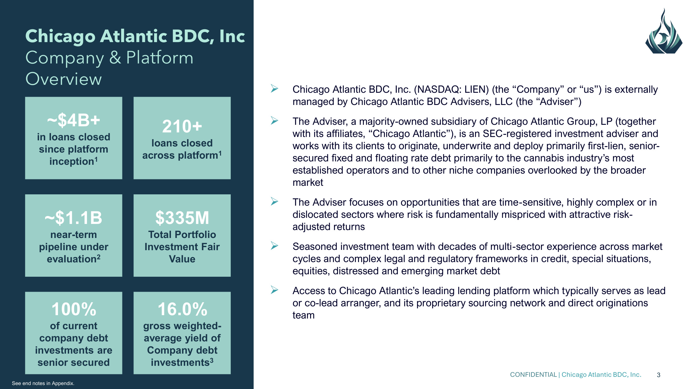
CONFIDENTIAL | Chicago Atlantic BDC, Inc. 3 Chicago Atlantic BDC, Inc Company & Platform Overview ~$1.1B near-term pipeline under evaluation2 ~$4B+ in loans closed since platform inception1 210+ loans closed across platform1 $335M Total Portfolio Investment Fair Value 16.0% gross weighted- average yield of Company debt investments3 100% of current company debt investments are senior secured ➢ Chicago Atlantic BDC, Inc. (NASDAQ: LIEN) (the "Company" or "us") is externally managed by Chicago Atlantic BDC Advisers, LLC (the "Adviser") ➢ The Adviser, a majority-owned subsidiary of Chicago Atlantic Group, LP (together with its affiliates, "Chicago Atlantic"), is an SEC-registered investment adviser and works with its clients to originate, underwrite and deploy primarily first-lien, senior- secured fixed and floating rate debt primarily to the cannabis industry's most established operators and to other niche companies overlooked by the broader market ➢ The Adviser focuses on opportunities that are time-sensitive, highly complex or in dislocated sectors where risk is fundamentally mispriced with attractive risk- adjusted returns ➢ Seasoned investment team with decades of multi-sector experience across market cycles and complex legal and regulatory frameworks in credit, special situations, equities, distressed and emerging market debt ➢ Access to Chicago Atlantic's leading lending platform which typically serves as lead or co-lead arranger, and its proprietary sourcing network and direct originations team See end notes in Appendix.

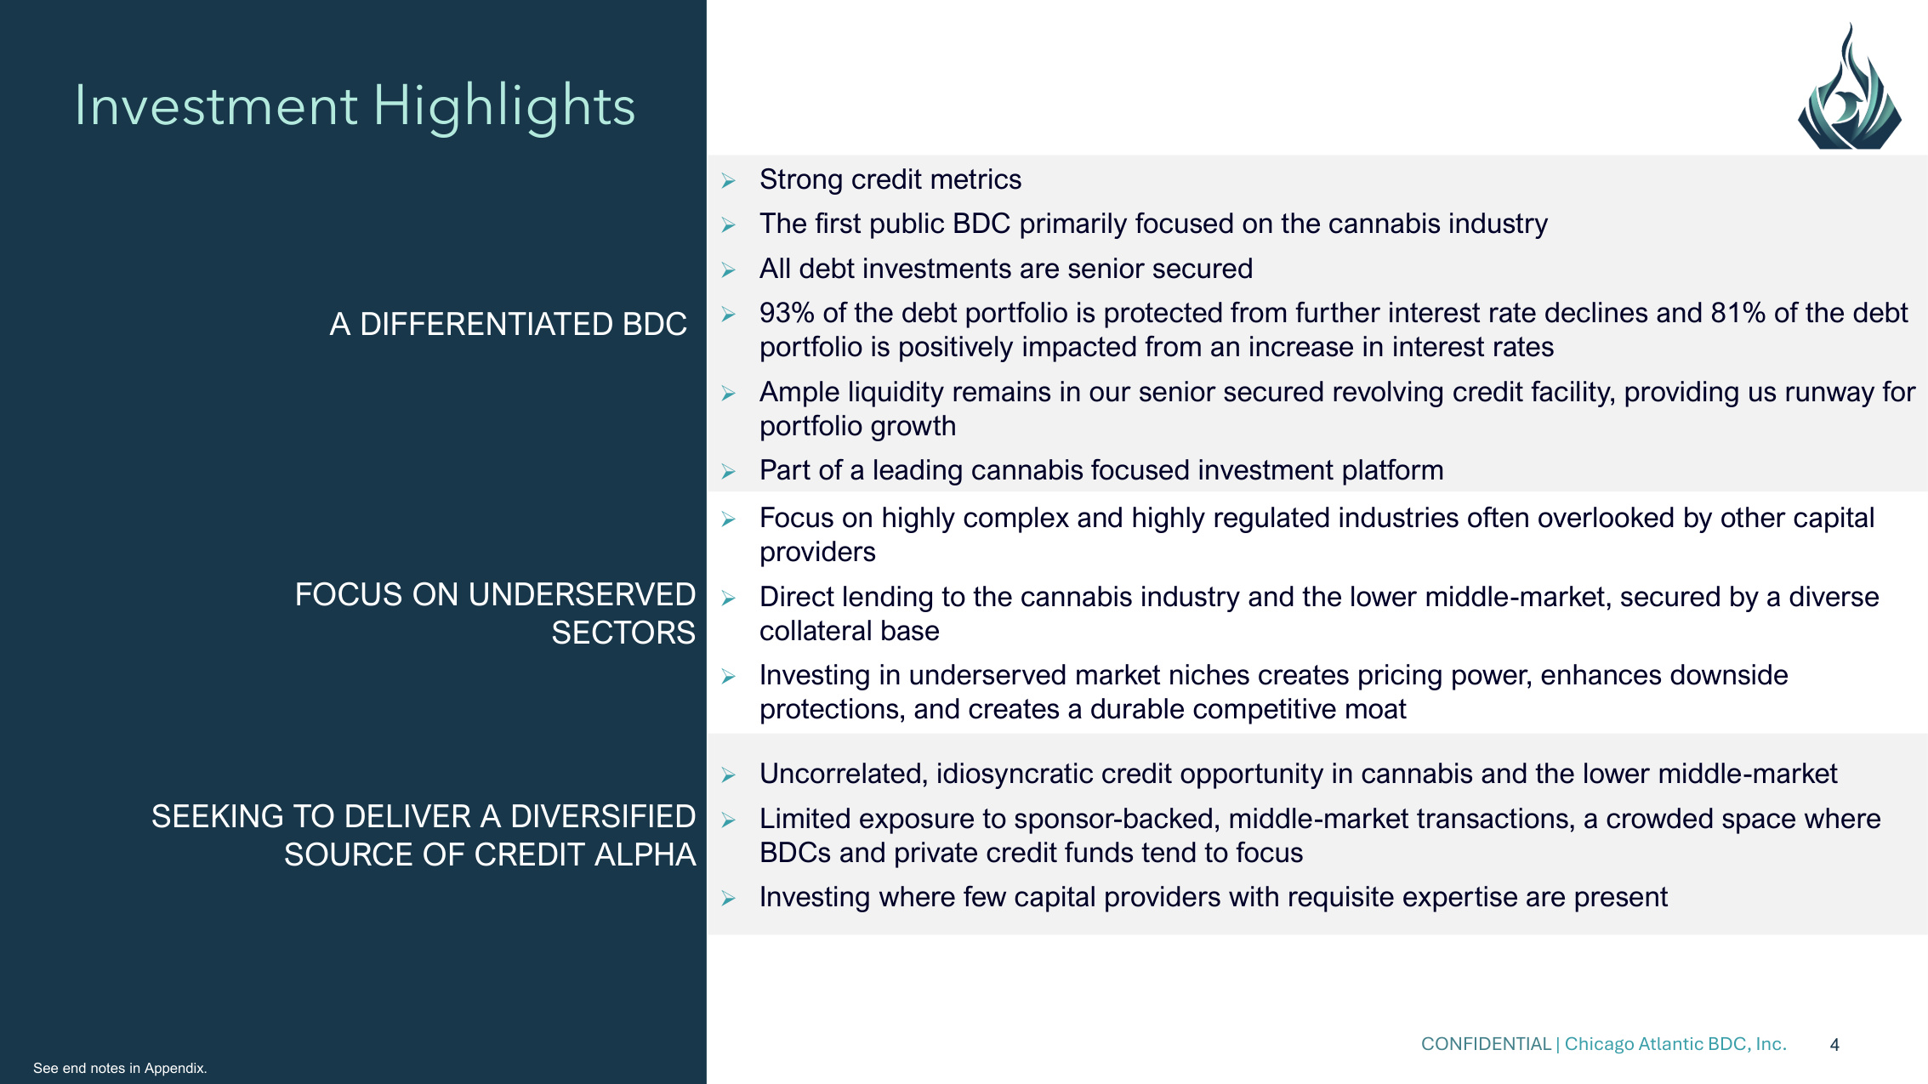
CONFIDENTIAL | Chicago Atlantic BDC, Inc. 4 Investment Highlights A DIFFERENTIATED BDC ➢Strong credit metrics ➢The first public BDC primarily focused on the cannabis industry ➢All debt investments are senior secured ➢93% of the debt portfolio is protected from further interest rate declines and 81% of the debt portfolio is positively impacted from an increase in interest rates ➢Ample liquidity remains in our senior secured revolving credit facility, providing us runway for portfolio growth ➢Part of a leading cannabis focused investment platform FOCUS ON UNDERSERVED SECTORS ➢Focus on highly complex and highly regulated industries often overlooked by other capital providers ➢Direct lending to the cannabis industry and the lower middle-market, secured by a diverse collateral base ➢Investing in underserved market niches creates pricing power, enhances downside protections, and creates a durable competitive moat SEEKING TO DELIVER A DIVERSIFIED SOURCE OF CREDIT ALPHA ➢Uncorrelated, idiosyncratic credit opportunity in cannabis and the lower middle-market ➢Limited exposure to sponsor-backed, middle-market transactions, a crowded space where BDCs and private credit funds tend to focus ➢Investing where few capital providers with requisite expertise are present See end notes in Appendix.

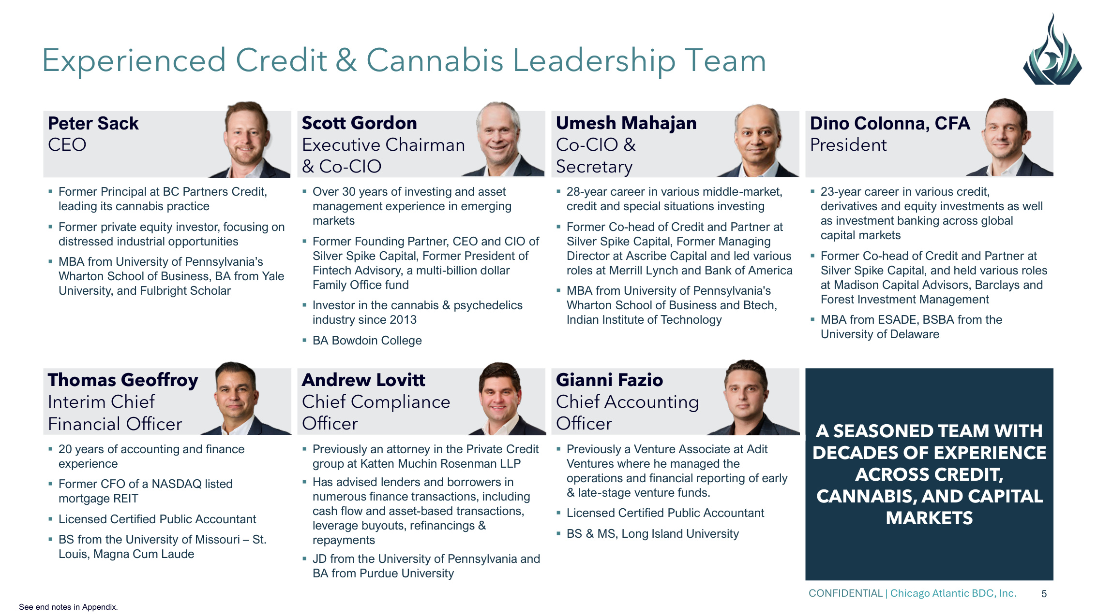
CONFIDENTIAL | Chicago Atlantic BDC, Inc. 5 Peter Sack CEO Scott Gordon Executive Chairman & Co-CIO Umesh Mahajan Co-CIO & Secretary Dino Colonna, CFA President ▪Former Principal at BC Partners Credit, leading its cannabis practice ▪Former private equity investor, focusing on distressed industrial opportunities ▪MBA from University of Pennsylvania's Wharton School of Business, BA from Yale University, and Fulbright Scholar ▪Over 30 years of investing and asset management experience in emerging markets ▪Former Founding Partner, CEO and CIO of Silver Spike Capital, Former President of Fintech Advisory, a multi-billion dollar Family Office fund ▪Investor in the cannabis & psychedelics industry since 2013 ▪BA Bowdoin College ▪28-year career in various middle-market, credit and special situations investing ▪Former Co-head of Credit and Partner at Silver Spike Capital, Former Managing Director at Ascribe Capital and led various roles at Merrill Lynch and Bank of America ▪MBA from University of Pennsylvania's Wharton School of Business and Btech, Indian Institute of Technology ▪23-year career in various credit, derivatives and equity investments as well as investment banking across global capital markets ▪Former Co-head of Credit and Partner at Silver Spike Capital, and held various roles at Madison Capital Advisors, Barclays and Forest Investment Management ▪MBA from ESADE, BSBA from the University of Delaware Thomas Geoffroy Interim Chief Financial Officer Andrew Lovitt Chief Compliance Officer Gianni Fazio Chief Accounting Officer A SEASONED TEAM WITH DECADES OF EXPERIENCE ACROSS CREDIT, CANNABIS, AND CAPITAL MARKETS ▪20 years of accounting and finance experience ▪Former CFO of a NASDAQ listed mortgage REIT ▪Licensed Certified Public Accountant ▪BS from the University of Missouri – St. Louis, Magna Cum Laude ▪Previously an attorney in the Private Credit group at Katten Muchin Rosenman LLP ▪Has advised lenders and borrowers in numerous finance transactions, including cash flow and asset-based transactions, leverage buyouts, refinancings & repayments ▪JD from the University of Pennsylvania and BA from Purdue University ▪Previously a Venture Associate at Adit Ventures where he managed the operations and financial reporting of early & late-stage venture funds. ▪Licensed Certified Public Accountant ▪BS & MS, Long Island University Experienced Credit & Cannabis Leadership Team See end notes in Appendix.

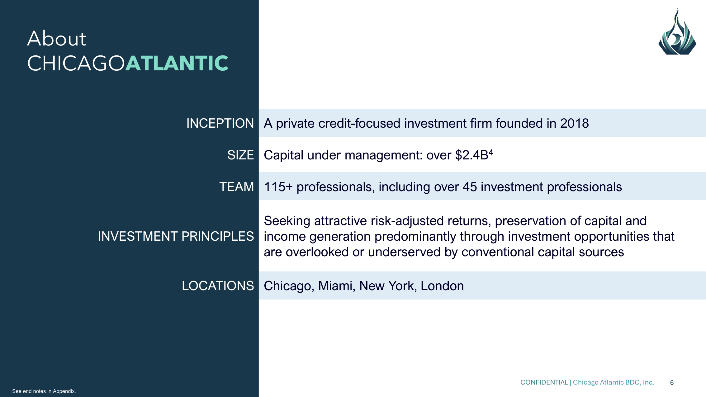
CONFIDENTIAL | Chicago Atlantic BDC, Inc. 6 About CHICAGOATLANTIC INCEPTION A private credit-focused investment firm founded in 2018 SIZE Capital under management: over $2.4B4 TEAM 115+ professionals, including over 45 investment professionals INVESTMENT PRINCIPLES Seeking attractive risk-adjusted returns, preservation of capital and income generation predominantly through investment opportunities that are overlooked or underserved by conventional capital sources LOCATIONS Chicago, Miami, New York, London See end notes in Appendix.

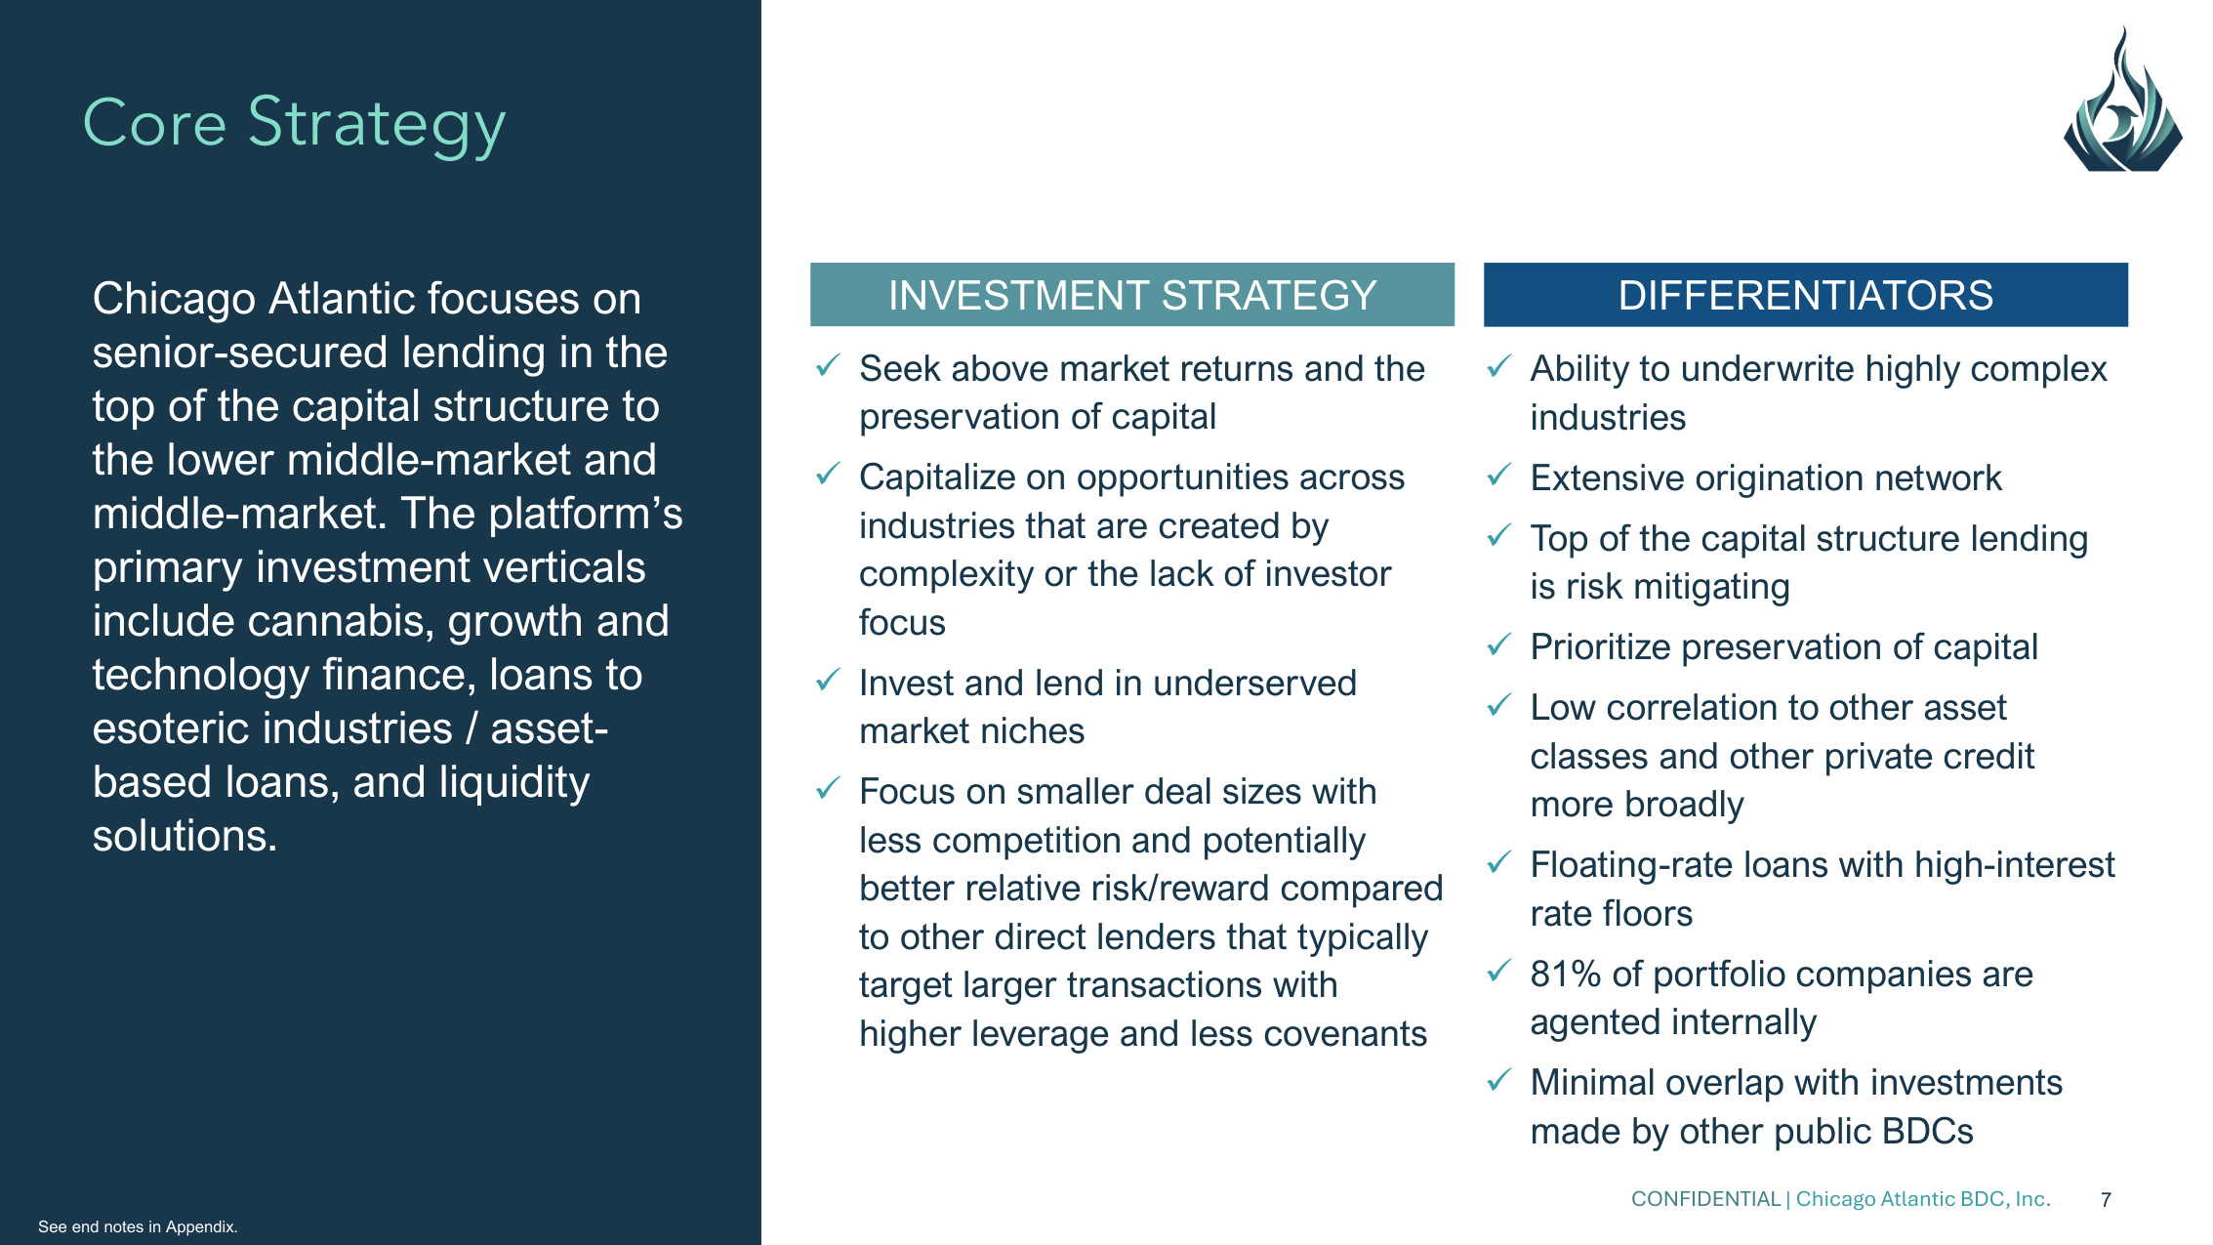
CONFIDENTIAL | Chicago Atlantic BDC, Inc. 7 Core Strategy Chicago Atlantic focuses on senior-secured lending in the top of the capital structure to the lower middle-market and middle-market. The platform's primary investment verticals include cannabis, growth and technology finance, loans to esoteric industries / asset- based loans, and liquidity solutions. INVESTMENT STRATEGY DIFFERENTIATORS ✓Seek above market returns and the preservation of capital ✓Capitalize on opportunities across industries that are created by complexity or the lack of investor focus ✓Invest and lend in underserved market niches ✓Focus on smaller deal sizes with less competition and potentially better relative risk/reward compared to other direct lenders that typically target larger transactions with higher leverage and less covenants ✓Ability to underwrite highly complex industries ✓Extensive origination network ✓Top of the capital structure lending is risk mitigating ✓Prioritize preservation of capital ✓Low correlation to other asset classes and other private credit more broadly ✓Floating-rate loans with high-interest rate floors ✓81% of portfolio companies are agented internally ✓Minimal overlap with investments made by other public BDCs See end notes in Appendix.

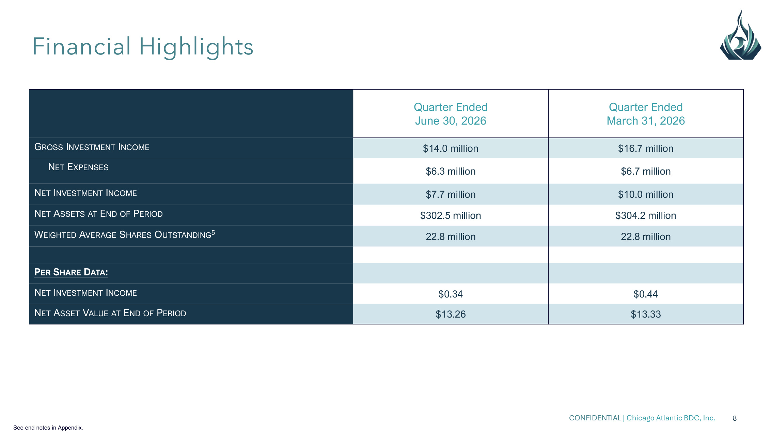
CONFIDENTIAL | Chicago Atlantic BDC, Inc. 8 Quarter Ended June 30, 2026 Quarter Ended March 31, 2026 GROSS INVESTMENT INCOME $14.0 million $16.7 million NET EXPENSES $6.3 million $6.7 million NET INVESTMENT INCOME $7.7 million $10.0 million NET ASSETS AT END OF PERIOD $302.5 million $304.2 million WEIGHTED AVERAGE SHARES OUTSTANDING5 22.8 million 22.8 million PER SHARE DATA: NET INVESTMENT INCOME $0.34 $0.44 NET ASSET VALUE AT END OF PERIOD $13.26 $13.33 See end notes in Appendix. Financial Highlights

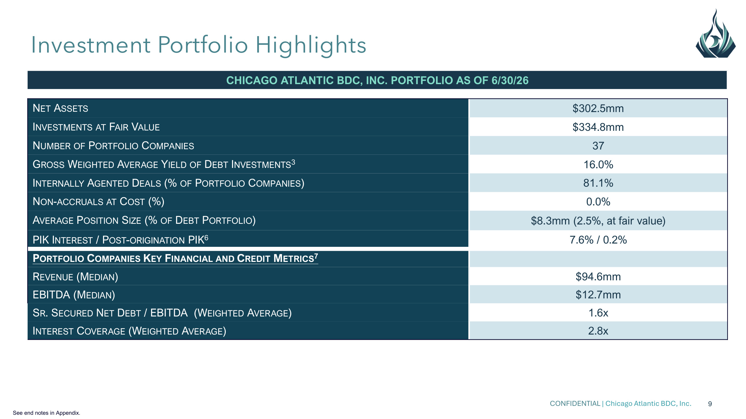
CONFIDENTIAL | Chicago Atlantic BDC, Inc. 9 CHICAGO ATLANTIC BDC, INC. PORTFOLIO AS OF 6/30/26 NET ASSETS $302.5mm INVESTMENTS AT FAIR VALUE $334.8mm NUMBER OF PORTFOLIO COMPANIES 37 GROSS WEIGHTED AVERAGE YIELD OF DEBT INVESTMENTS3 16.0% INTERNALLY AGENTED DEALS (% OF PORTFOLIO COMPANIES) 81.1% NON-ACCRUALS AT COST (%) 0.0% AVERAGE POSITION SIZE (% OF DEBT PORTFOLIO) $8.3mm (2.5%, at fair value) PIK INTEREST / POST-ORIGINATION PIK6 7.6% / 0.2% PORTFOLIO COMPANIES KEY FINANCIAL AND CREDIT METRICS7 REVENUE (MEDIAN) $94.6mm EBITDA (MEDIAN) $12.7mm SR. SECURED NET DEBT / EBITDA (WEIGHTED AVERAGE) 1.6x INTEREST COVERAGE (WEIGHTED AVERAGE) 2.8x See end notes in Appendix. Investment Portfolio Highlights

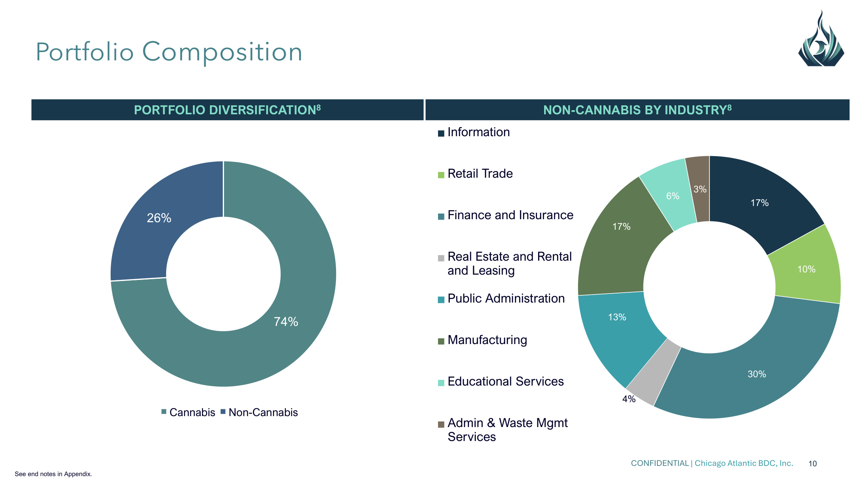
CONFIDENTIAL | Chicago Atlantic BDC, Inc. 10 74% 26% Cannabis Non-Cannabis NON-CANNABIS BY INDUSTRY8 PORTFOLIO DIVERSIFICATION8 Portfolio Composition 17% 10% 30% 4% 13% 17% 6% 3% Information Retail Trade Finance and Insurance Real Estate and Rental and Leasing Public Administration Manufacturing Educational Services Admin & Waste Mgmt Services See end notes in Appendix.

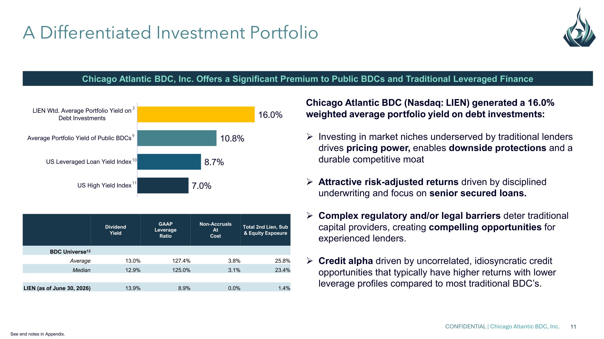
CONFIDENTIAL | Chicago Atlantic BDC, Inc. 11 A Differentiated Investment Portfolio Chicago Atlantic BDC, Inc. Offers a Significant Premium to Public BDCs and Traditional Leveraged Finance Chicago Atlantic BDC (Nasdaq: LIEN) generated a 16.0% weighted average portfolio yield on debt investments: ➢Investing in market niches underserved by traditional lenders drives pricing power, enables downside protections and a durable competitive moat ➢Attractive risk-adjusted returns driven by disciplined underwriting and focus on senior secured loans. ➢Complex regulatory and/or legal barriers deter traditional capital providers, creating compelling opportunities for experienced lenders. ➢Credit alpha driven by uncorrelated, idiosyncratic credit opportunities that typically have higher returns with lower leverage profiles compared to most traditional BDC's. 7.0% 8.7% 10.8% 16.0% US High Yield Index US Leveraged Loan Yield Index Average Portfolio Yield of Public BDCs LIEN Wtd. Average Portfolio Yield on Debt Investments 3 9 10 11 Dividend Yield GAAP Leverage Ratio Non-Accruals At Cost Total 2nd Lien, Sub & Equity Exposure BDC Universe12 Average 13.0% 127.4% 3.8% 25.8% Median 12.9% 125.0% 3.1% 23.4% LIEN (as of June 30, 2026) 13.9% 8.9% 0.0% 1.4% See end notes in Appendix.

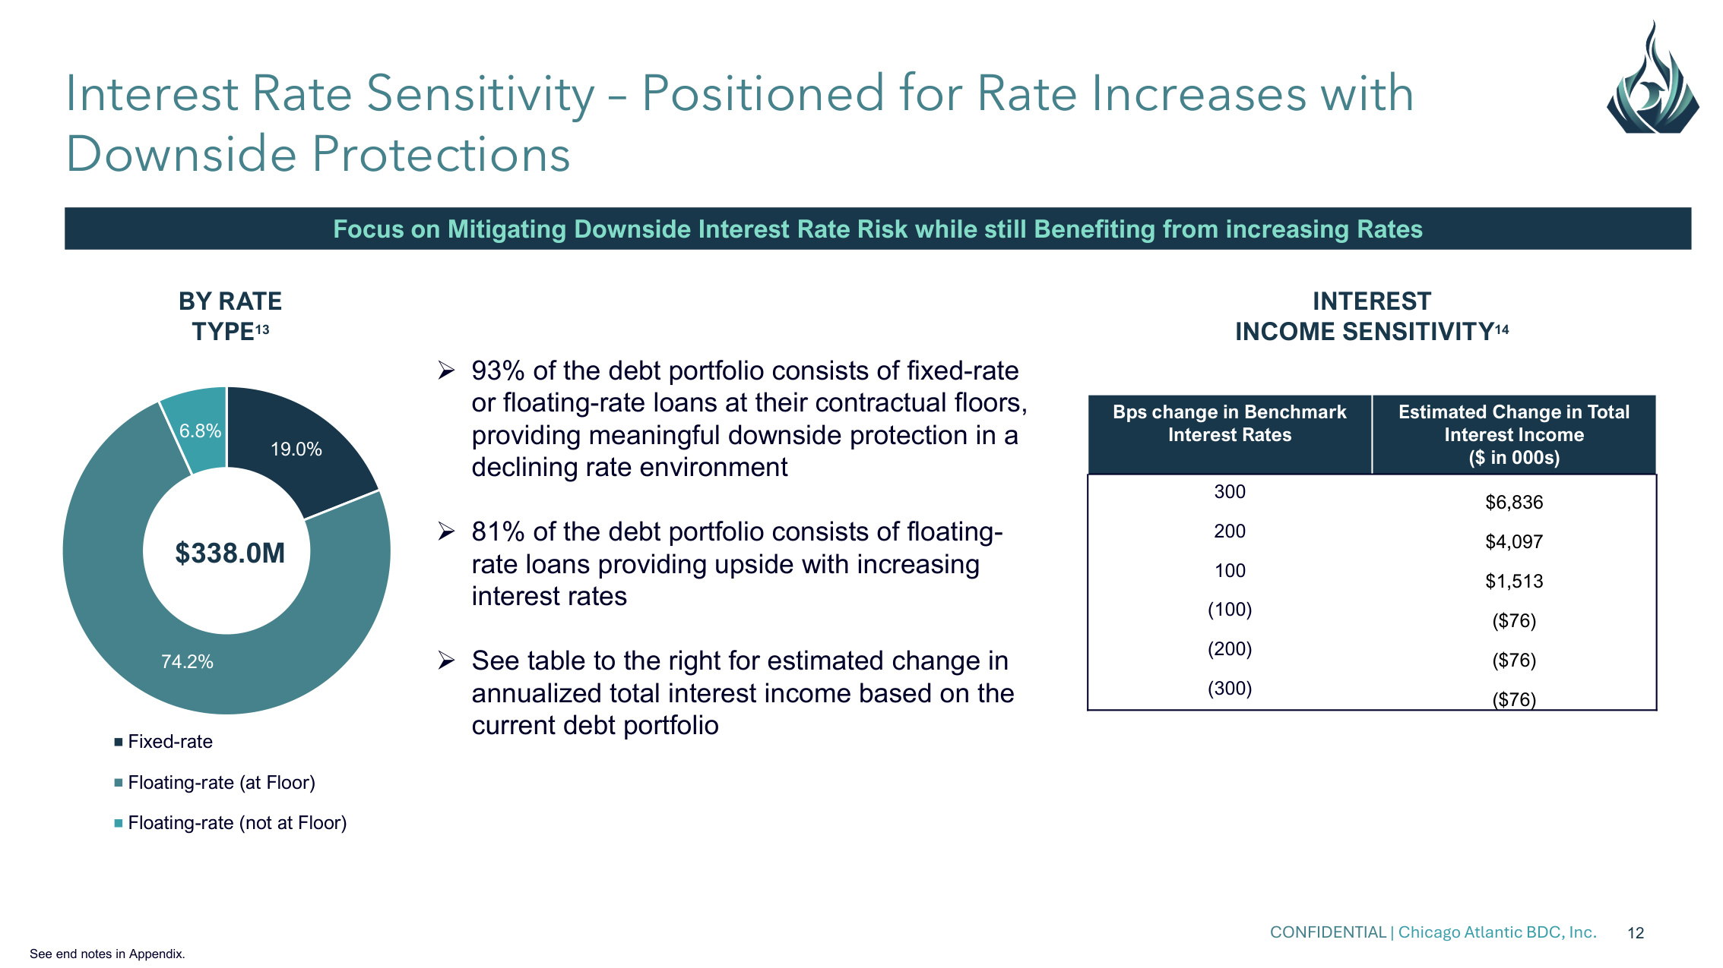
CONFIDENTIAL | Chicago Atlantic BDC, Inc. 12 Interest Rate Sensitivity – Positioned for Rate Increases with Downside Protections BY RATE TYPE13 19.0% 74.2% 6.8% Fixed-rate Floating-rate (at Floor) Floating-rate (not at Floor) $338.0M INTEREST INCOME SENSITIVITY14 Bps change in Benchmark Interest Rates Estimated Change in Total Interest Income ($ in 000s) 300 $6,836 200 $4,097 100 $1,513 (100) ($76) (200) ($76) (300) ($76) Focus on Mitigating Downside Interest Rate Risk while still Benefiting from increasing Rates ➢93% of the debt portfolio consists of fixed-rate or floating-rate loans at their contractual floors, providing meaningful downside protection in a declining rate environment ➢81% of the debt portfolio consists of floating- rate loans providing upside with increasing interest rates ➢See table to the right for estimated change in annualized total interest income based on the current debt portfolio See end notes in Appendix.

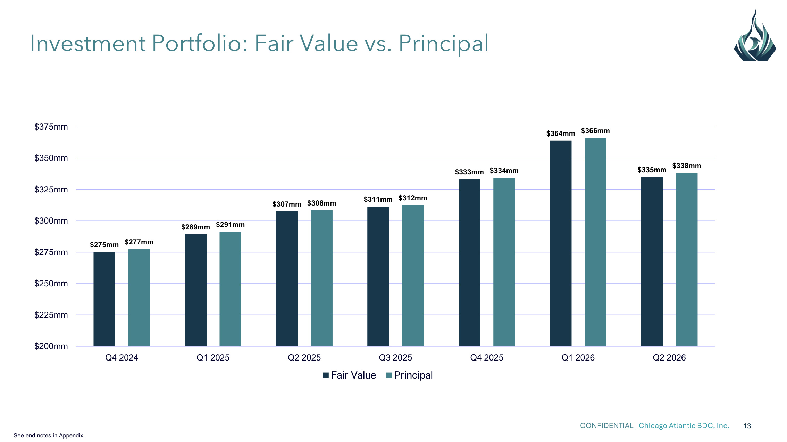
CONFIDENTIAL | Chicago Atlantic BDC, Inc. 13 Investment Portfolio: Fair Value vs. Principal $275mm $289mm $307mm $311mm $333mm $364mm $335mm $277mm $291mm $308mm $312mm $334mm $366mm $338mm $200mm $225mm $250mm $275mm $300mm $325mm $350mm $375mm Q4 2024 Q1 2025 Q2 2025 Q3 2025 Q4 2025 Q1 2026 Q2 2026 Fair Value Principal See end notes in Appendix.

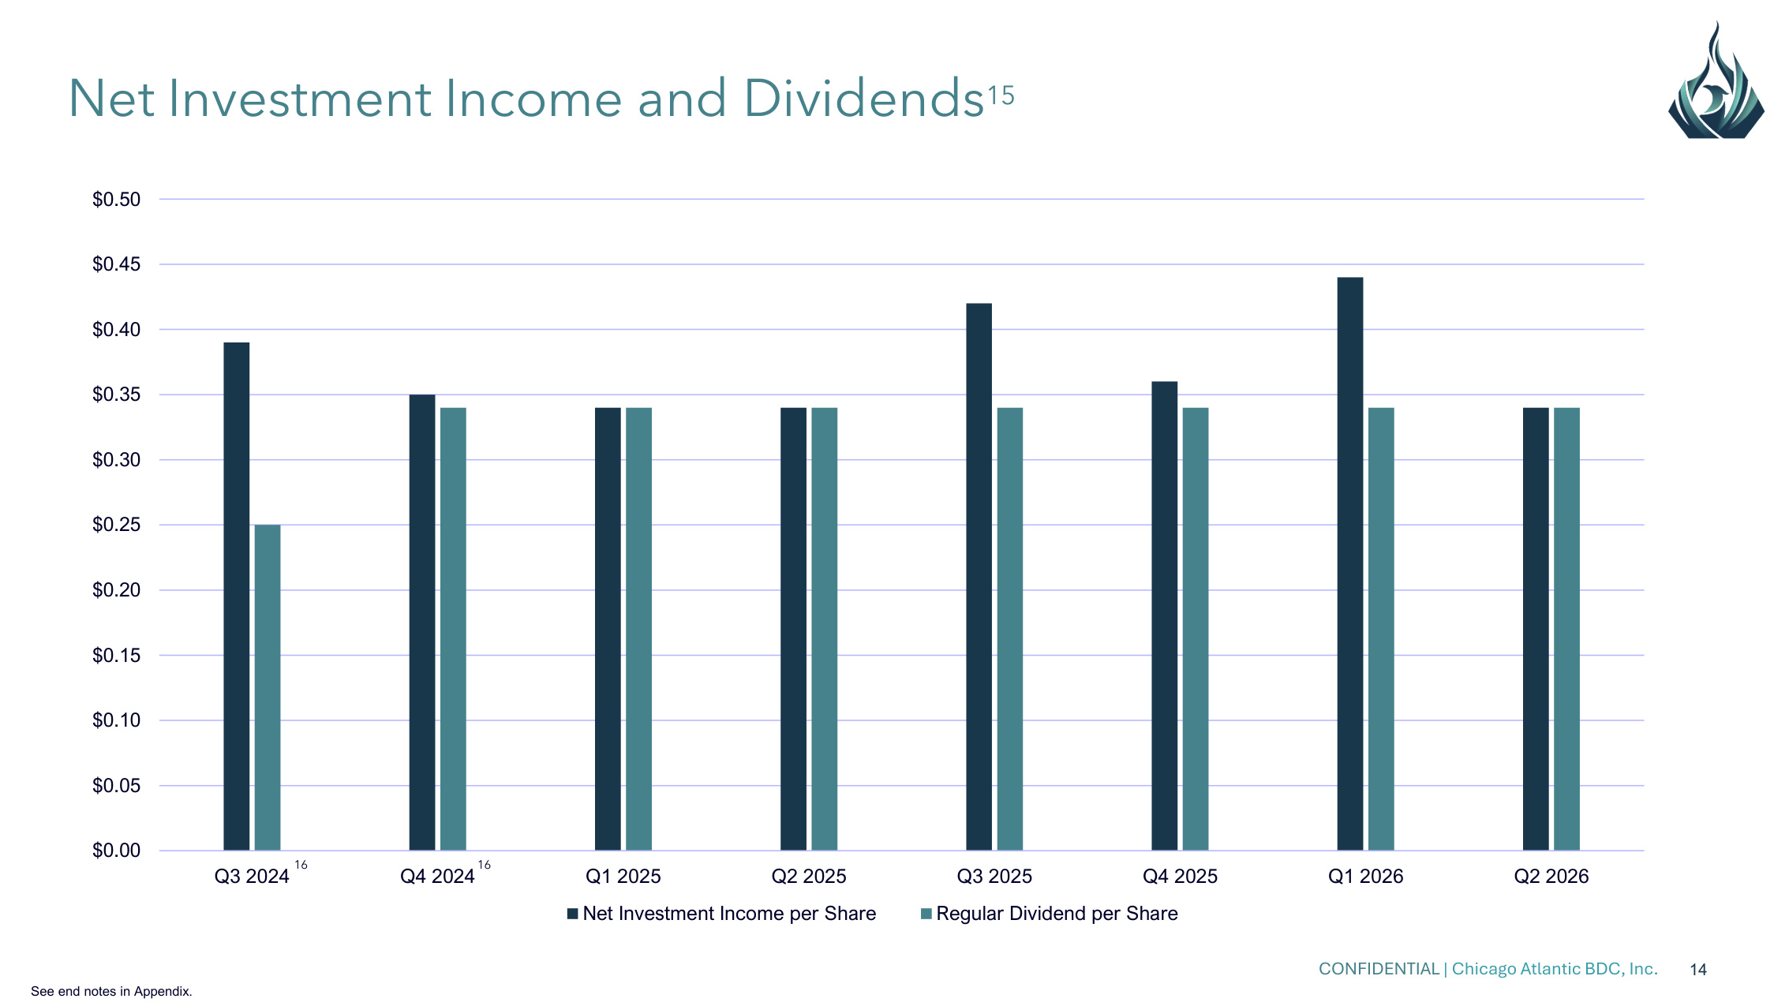
CONFIDENTIAL | Chicago Atlantic BDC, Inc. 14 $0.00 $0.05 $0.10 $0.15 $0.20 $0.25 $0.30 $0.35 $0.40 $0.45 $0.50 Q3 2024 Q4 2024 Q1 2025 Q2 2025 Q3 2025 Q4 2025 Q1 2026 Q2 2026 Net Investment Income per Share Regular Dividend per Share Net Investment Income and Dividends15 16 16 See end notes in Appendix.

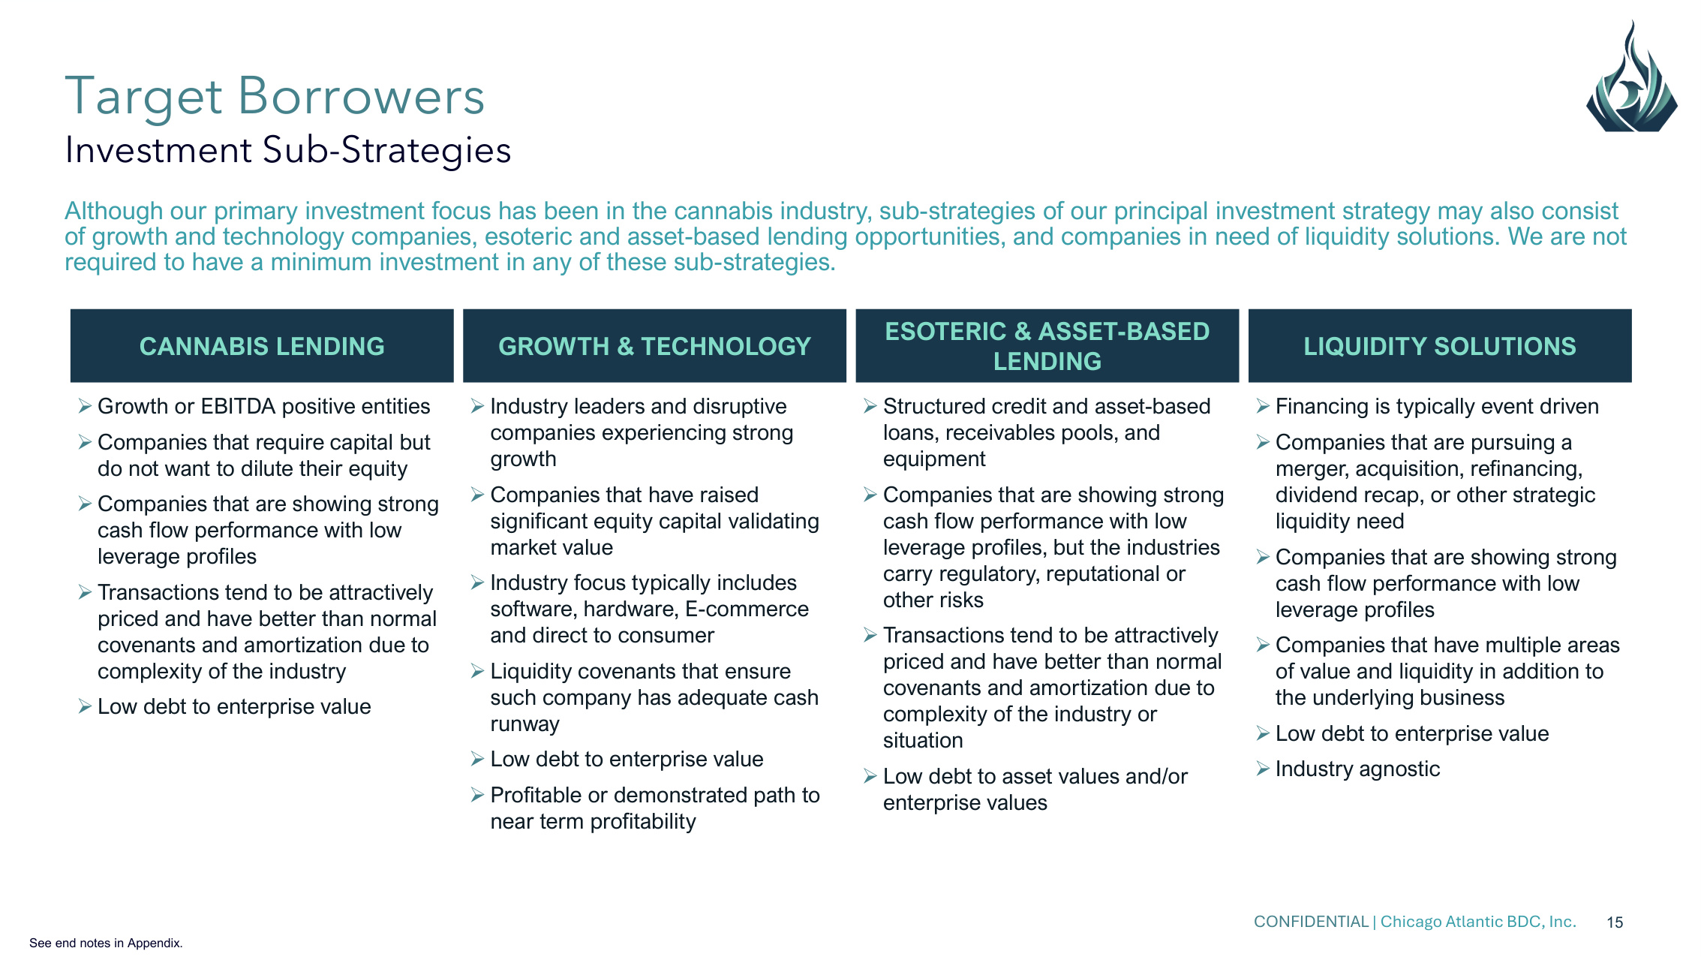
CONFIDENTIAL | Chicago Atlantic BDC, Inc. 15 Target Borrowers Investment Sub-Strategies CANNABIS LENDING GROWTH & TECHNOLOGY ESOTERIC & ASSET-BASED LENDING LIQUIDITY SOLUTIONS ➢Growth or EBITDA positive entities ➢Companies that require capital but do not want to dilute their equity ➢Companies that are showing strong cash flow performance with low leverage profiles ➢Transactions tend to be attractively priced and have better than normal covenants and amortization due to complexity of the industry ➢Low debt to enterprise value ➢Industry leaders and disruptive companies experiencing strong growth ➢Companies that have raised significant equity capital validating market value ➢Industry focus typically includes software, hardware, E-commerce and direct to consumer ➢Liquidity covenants that ensure such company has adequate cash runway ➢Low debt to enterprise value ➢Profitable or demonstrated path to near term profitability ➢Structured credit and asset-based loans, receivables pools, and equipment ➢Companies that are showing strong cash flow performance with low leverage profiles, but the industries carry regulatory, reputational or other risks ➢Transactions tend to be attractively priced and have better than normal covenants and amortization due to complexity of the industry or situation ➢Low debt to asset values and/or enterprise values ➢Financing is typically event driven ➢Companies that are pursuing a merger, acquisition, refinancing, dividend recap, or other strategic liquidity need ➢Companies that are showing strong cash flow performance with low leverage profiles ➢Companies that have multiple areas of value and liquidity in addition to the underlying business ➢Low debt to enterprise value ➢Industry agnostic Although our primary investment focus has been in the cannabis industry, sub-strategies of our principal investment strategy may also consist of growth and technology companies, esoteric and asset-based lending opportunities, and companies in need of liquidity solutions. We are not required to have a minimum investment in any of these sub-strategies. See end notes in Appendix.

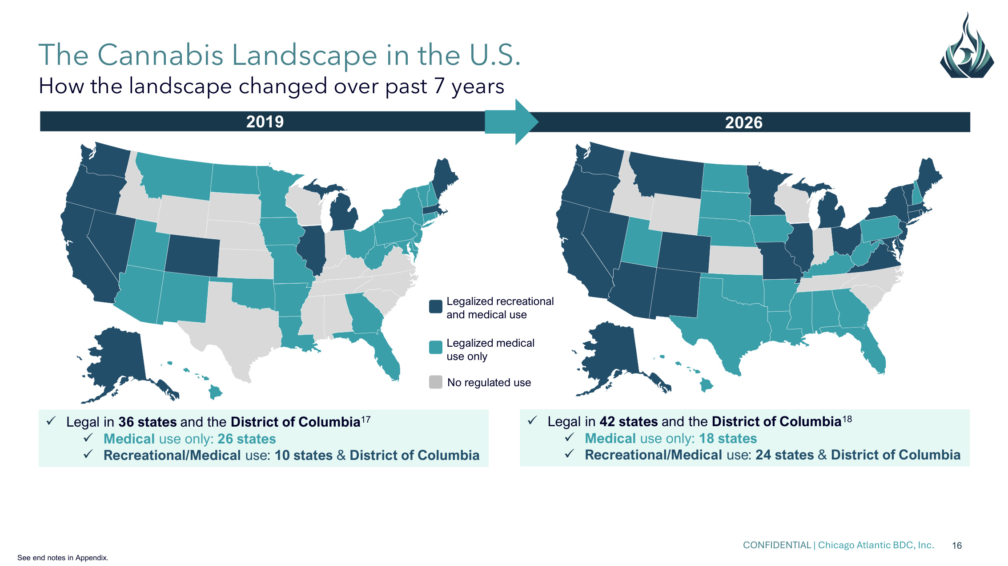
CONFIDENTIAL | Chicago Atlantic BDC, Inc. 16 The Cannabis Landscape in the U.S. How the landscape changed over past 7 years 2019 2026 ✓Legal in 42 states and the District of Columbia18 ✓Medical use only: 18 states ✓Recreational/Medical use: 24 states & District of Columbia ✓Legal in 36 states and the District of Columbia17 ✓Medical use only: 26 states ✓Recreational/Medical use: 10 states & District of Columbia No regulated use Legalized recreational and medical use Legalized medical use only See end notes in Appendix.

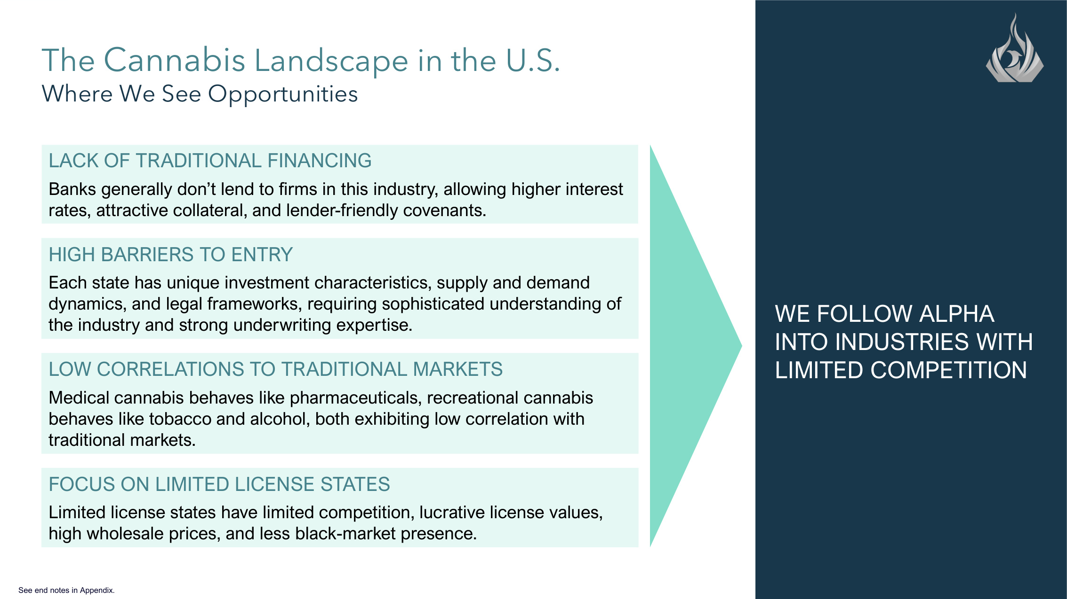
CONFIDENTIAL | Chicago Atlantic BDC, Inc. 17 The Cannabis Landscape in the U.S. Where We See Opportunities WE FOLLOW ALPHA INTO INDUSTRIES WITH LIMITED COMPETITION LACK OF TRADITIONAL FINANCING Banks generally don't lend to firms in this industry, allowing higher interest rates, attractive collateral, and lender-friendly covenants. LOW CORRELATIONS TO TRADITIONAL MARKETS Medical cannabis behaves like pharmaceuticals, recreational cannabis behaves like tobacco and alcohol, both exhibiting low correlation with traditional markets. HIGH BARRIERS TO ENTRY Each state has unique investment characteristics, supply and demand dynamics, and legal frameworks, requiring sophisticated understanding of the industry and strong underwriting expertise. FOCUS ON LIMITED LICENSE STATES Limited license states have limited competition, lucrative license values, high wholesale prices, and less black-market presence. See end notes in Appendix.

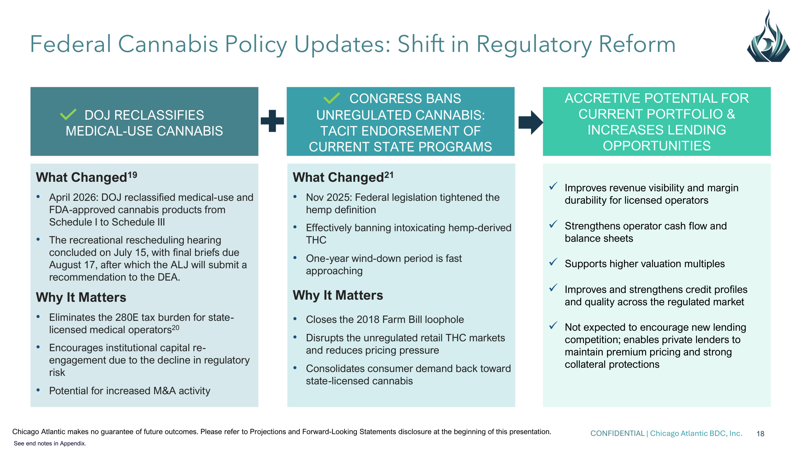
CONFIDENTIAL | Chicago Atlantic BDC, Inc. 18 Federal Cannabis Policy Updates: Shift in Regulatory Reform Chicago Atlantic makes no guarantee of future outcomes. Please refer to Projections and Forward-Looking Statements disclosure at the beginning of this presentation. DOJ RECLASSIFIES MEDICAL-USE CANNABIS CONGRESS BANS UNREGULATED CANNABIS: TACIT ENDORSEMENT OF CURRENT STATE PROGRAMS What Changed19 • April 2026: DOJ reclassified medical-use and FDA-approved cannabis products from Schedule I to Schedule III • The recreational rescheduling hearing concluded on July 15, with final briefs due August 17, after which the ALJ will submit a recommendation to the DEA. Why It Matters • Eliminates the 280E tax burden for state- licensed medical operators20 • Encourages institutional capital re- engagement due to the decline in regulatory risk • Potential for increased M&A activity What Changed21 • Nov 2025: Federal legislation tightened the hemp definition • Effectively banning intoxicating hemp-derived THC • One-year wind-down period is fast approaching Why It Matters • Closes the 2018 Farm Bill loophole • Disrupts the unregulated retail THC markets and reduces pricing pressure • Consolidates consumer demand back toward state-licensed cannabis ACCRETIVE POTENTIAL FOR CURRENT PORTFOLIO & INCREASES LENDING OPPORTUNITIES ✓Improves revenue visibility and margin durability for licensed operators ✓Strengthens operator cash flow and balance sheets ✓Supports higher valuation multiples ✓Improves and strengthens credit profiles and quality across the regulated market ✓Not expected to encourage new lending competition; enables private lenders to maintain premium pricing and strong collateral protections See end notes in Appendix.

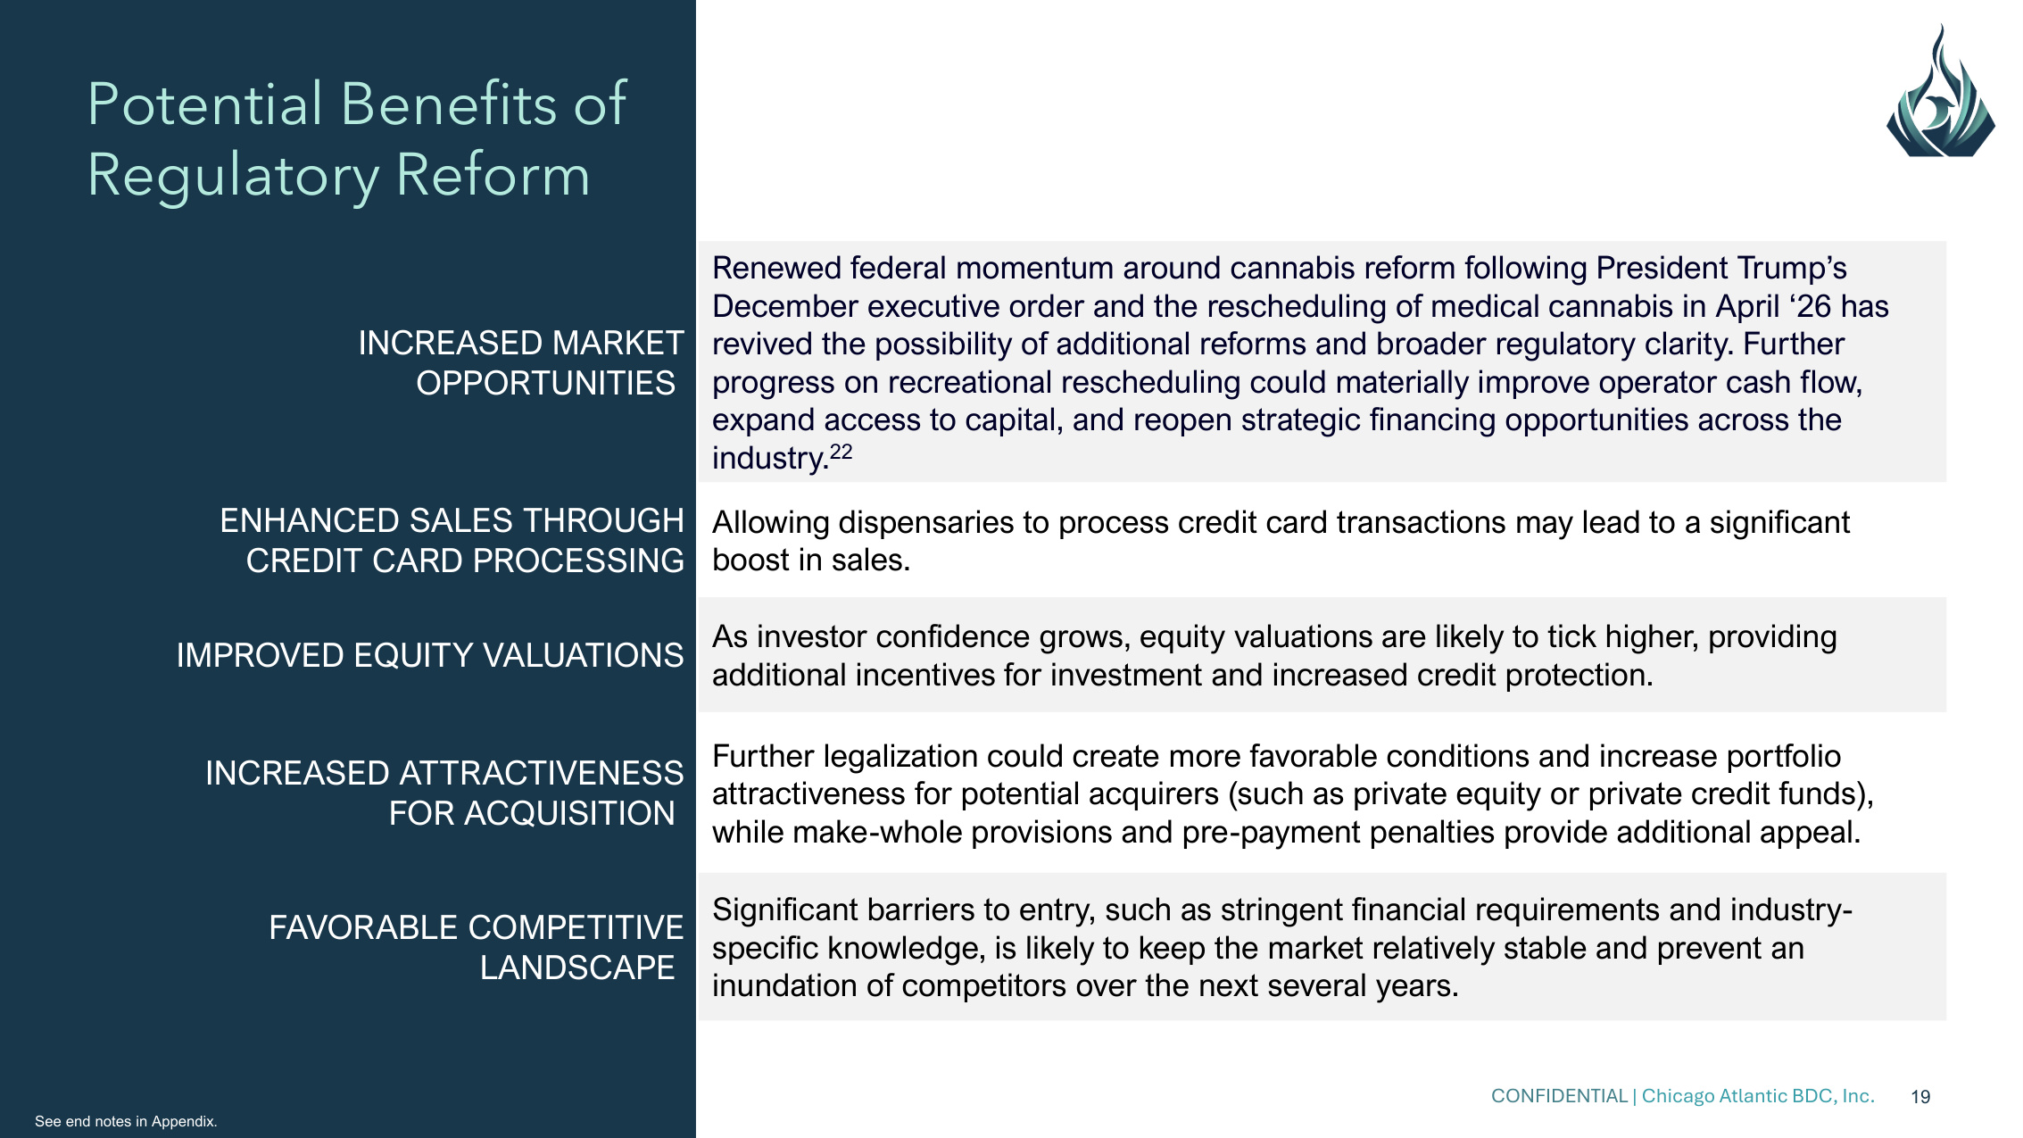
CONFIDENTIAL | Chicago Atlantic BDC, Inc. 19 Potential Benefits of Regulatory Reform INCREASED MARKET OPPORTUNITIES Renewed federal momentum around cannabis reform following President Trump's December executive order and the rescheduling of medical cannabis in April '26 has revived the possibility of additional reforms and broader regulatory clarity. Further progress on recreational rescheduling could materially improve operator cash flow, expand access to capital, and reopen strategic financing opportunities across the industry.22 ENHANCED SALES THROUGH CREDIT CARD PROCESSING Allowing dispensaries to process credit card transactions may lead to a significant boost in sales. IMPROVED EQUITY VALUATIONS As investor confidence grows, equity valuations are likely to tick higher, providing additional incentives for investment and increased credit protection. INCREASED ATTRACTIVENESS FOR ACQUISITION Further legalization could create more favorable conditions and increase portfolio attractiveness for potential acquirers (such as private equity or private credit funds), while make-whole provisions and pre-payment penalties provide additional appeal. FAVORABLE COMPETITIVE LANDSCAPE Significant barriers to entry, such as stringent financial requirements and industry- specific knowledge, is likely to keep the market relatively stable and prevent an inundation of competitors over the next several years. See end notes in Appendix.


Appendix:

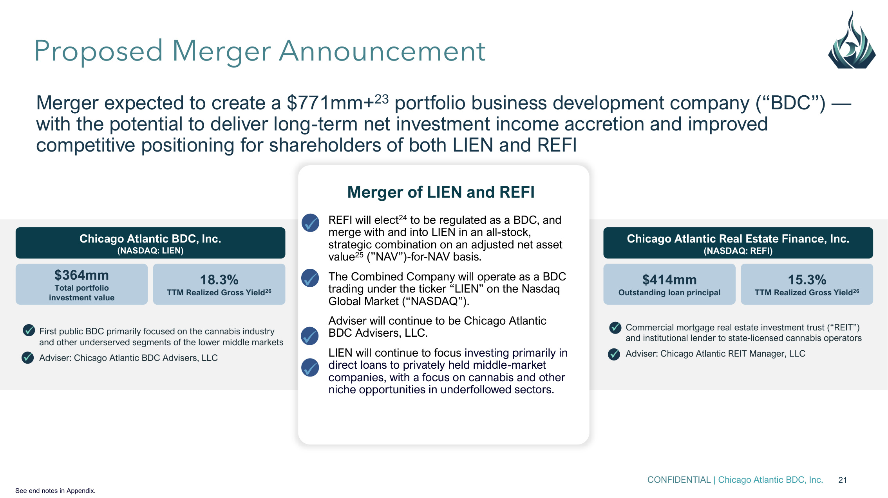
CONFIDENTIAL | Chicago Atlantic BDC, Inc. 21 Merger expected to create a $771mm+23 portfolio business development company ("BDC") — with the potential to deliver long-term net investment income accretion and improved competitive positioning for shareholders of both LIEN and REFI Proposed Merger Announcement Commercial mortgage real estate investment trust ("REIT") and institutional lender to state-licensed cannabis operators Adviser: Chicago Atlantic REIT Manager, LLC ✓ ✓ Chicago Atlantic Real Estate Finance, Inc. (NASDAQ: REFI) $414mm Outstanding loan principal 15.3% TTM Realized Gross Yield26 First public BDC primarily focused on the cannabis industry and other underserved segments of the lower middle markets Adviser: Chicago Atlantic BDC Advisers, LLC ✓ ✓ Chicago Atlantic BDC, Inc. (NASDAQ: LIEN) $364mm Total portfolio investment value 18.3% TTM Realized Gross Yield26 a REFI will elect24 to be regulated as a BDC, and merge with and into LIEN in an all-stock, strategic combination on an adjusted net asset value25 ("NAV")-for-NAV basis. The Combined Company will operate as a BDC trading under the ticker "LIEN" on the Nasdaq Global Market ("NASDAQ"). Adviser will continue to be Chicago Atlantic BDC Advisers, LLC. LIEN will continue to focus investing primarily in direct loans to privately held middle-market companies, with a focus on cannabis and other niche opportunities in underfollowed sectors. Merger of LIEN and REFI ✓ ✓ ✓ ✓ See end notes in Appendix.

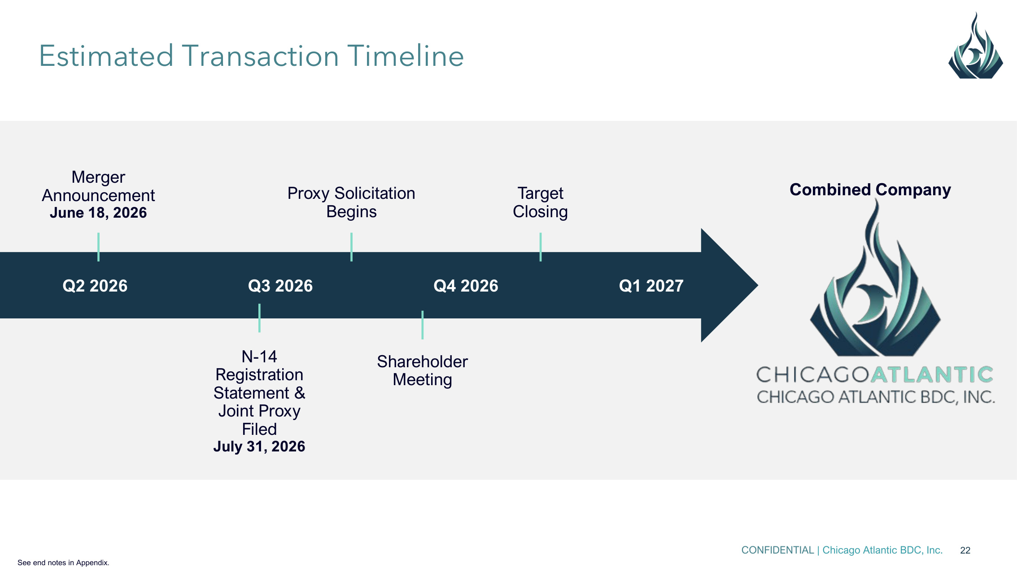
CONFIDENTIAL | Chicago Atlantic BDC, Inc. 22 Q2 2026 Merger Announcement June 18, 2026 Q3 2026 Q4 2026 Target Closing Proxy Solicitation Begins Combined Company Q1 2027 Estimated Transaction Timeline N-14 Registration Statement & Joint Proxy Filed July 31, 2026 Shareholder Meeting See end notes in Appendix.

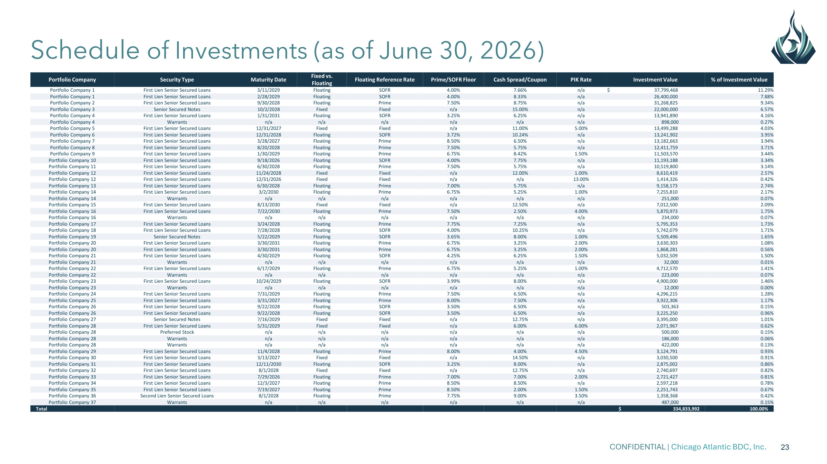
CONFIDENTIAL | Chicago Atlantic BDC, Inc. 23 Schedule of Investments (as of June 30, 2026) Portfolio Company Security Type Maturity Date Fixed vs. Floating Floating Reference Rate Prime/SOFR Floor Cash Spread/Coupon PIK Rate Investment Value % of Investment Value Portfolio Company 1 First Lien Senior Secured Loans 3/11/2029 Floating SOFR 4.00% 7.66% n/a $ 37,799,468 11.29% Portfolio Company 1 First Lien Senior Secured Loans 2/28/2029 Floating SOFR 4.00% 8.33% n/a 26,400,000 7.88% Portfolio Company 2 First Lien Senior Secured Loans 9/30/2028 Floating Prime 7.50% 8.75% n/a 31,268,825 9.34% Portfolio Company 3 Senior Secured Notes 10/2/2028 Fixed Fixed n/a 15.00% n/a 22,000,000 6.57% Portfolio Company 4 First Lien Senior Secured Loans 1/31/2031 Floating SOFR 3.25% 6.25% n/a 13,941,890 4.16% Portfolio Company 4 Warrants n/a n/a n/a n/a n/a n/a 898,000 0.27% Portfolio Company 5 First Lien Senior Secured Loans 12/31/2027 Fixed Fixed n/a 11.00% 5.00% 13,499,288 4.03% Portfolio Company 6 First Lien Senior Secured Loans 12/31/2028 Floating SOFR 3.72% 10.24% n/a 13,241,902 3.95% Portfolio Company 7 First Lien Senior Secured Loans 3/28/2027 Floating Prime 8.50% 6.50% n/a 13,182,663 3.94% Portfolio Company 8 First Lien Senior Secured Loans 8/20/2028 Floating Prime 7.50% 5.75% n/a 12,411,759 3.71% Portfolio Company 9 First Lien Senior Secured Loans 1/30/2029 Floating Prime 6.75% 8.42% 1.50% 11,503,570 3.44% Portfolio Company 10 First Lien Senior Secured Loans 9/18/2026 Floating SOFR 4.00% 7.75% n/a 11,193,188 3.34% Portfolio Company 11 First Lien Senior Secured Loans 6/30/2028 Floating Prime 7.50% 5.75% n/a 10,519,800 3.14% Portfolio Company 12 First Lien Senior Secured Loans 11/24/2028 Fixed Fixed n/a 12.00% 1.00% 8,610,419 2.57% Portfolio Company 12 First Lien Senior Secured Loans 12/31/2026 Fixed Fixed n/a n/a 13.00% 1,414,326 0.42% Portfolio Company 13 First Lien Senior Secured Loans 6/30/2028 Floating Prime 7.00% 5.75% n/a 9,158,173 2.74% Portfolio Company 14 First Lien Senior Secured Loans 3/2/2030 Floating Prime 6.75% 5.25% 1.00% 7,255,810 2.17% Portfolio Company 14 Warrants n/a n/a n/a n/a n/a n/a 251,000 0.07% Portfolio Company 15 First Lien Senior Secured Loans 8/13/2030 Fixed Fixed n/a 12.50% n/a 7,012,500 2.09% Portfolio Company 16 First Lien Senior Secured Loans 7/22/2030 Floating Prime 7.50% 2.50% 4.00% 5,870,973 1.75% Portfolio Company 16 Warrants n/a n/a n/a n/a n/a n/a 234,000 0.07% Portfolio Company 17 First Lien Senior Secured Loans 3/24/2028 Floating Prime 7.75% 7.25% n/a 5,795,353 1.73% Portfolio Company 18 First Lien Senior Secured Loans 7/28/2028 Floating SOFR 4.00% 10.25% n/a 5,742,079 1.71% Portfolio Company 19 Senior Secured Notes 5/22/2029 Floating SOFR 3.65% 8.00% 1.00% 5,509,496 1.65% Portfolio Company 20 First Lien Senior Secured Loans 3/30/2031 Floating Prime 6.75% 3.25% 2.00% 3,630,303 1.08% Portfolio Company 20 First Lien Senior Secured Loans 3/30/2031 Floating Prime 6.75% 3.25% 2.00% 1,868,281 0.56% Portfolio Company 21 First Lien Senior Secured Loans 4/30/2029 Floating SOFR 4.25% 6.25% 1.50% 5,032,509 1.50% Portfolio Company 21 Warrants n/a n/a n/a n/a n/a n/a 32,000 0.01% Portfolio Company 22 First Lien Senior Secured Loans 6/17/2029 Floating Prime 6.75% 5.25% 1.00% 4,712,570 1.41% Portfolio Company 22 Warrants n/a n/a n/a n/a n/a n/a 223,000 0.07% Portfolio Company 23 First Lien Senior Secured Loans 10/24/2029 Floating SOFR 3.99% 8.00% n/a 4,900,000 1.46% Portfolio Company 23 Warrants n/a n/a n/a n/a n/a n/a 12,000 0.00% Portfolio Company 24 First Lien Senior Secured Loans 7/31/2029 Floating Prime 7.50% 6.50% n/a 4,296,215 1.28% Portfolio Company 25 First Lien Senior Secured Loans 3/31/2027 Floating Prime 8.00% 7.50% n/a 3,922,306 1.17% Portfolio Company 26 First Lien Senior Secured Loans 9/22/2028 Floating SOFR 3.50% 6.50% n/a 503,363 0.15% Portfolio Company 26 First Lien Senior Secured Loans 9/22/2028 Floating SOFR 3.50% 6.50% n/a 3,225,250 0.96% Portfolio Company 27 Senior Secured Notes 7/16/2029 Fixed Fixed n/a 12.75% n/a 3,395,000 1.01% Portfolio Company 28 First Lien Senior Secured Loans 5/31/2029 Fixed Fixed n/a 6.00% 6.00% 2,071,967 0.62% Portfolio Company 28 Preferred Stock n/a n/a n/a n/a n/a n/a 500,000 0.15% Portfolio Company 28 Warrants n/a n/a n/a n/a n/a n/a 186,000 0.06% Portfolio Company 28 Warrants n/a n/a n/a n/a n/a n/a 422,000 0.13% Portfolio Company 29 First Lien Senior Secured Loans 11/4/2028 Floating Prime 8.00% 4.00% 4.50% 3,124,791 0.93% Portfolio Company 30 First Lien Senior Secured Loans 3/13/2027 Fixed Fixed n/a 14.50% n/a 3,030,500 0.91% Portfolio Company 31 First Lien Senior Secured Loans 12/11/2030 Floating SOFR 3.25% 8.00% n/a 2,875,002 0.86% Portfolio Company 32 First Lien Senior Secured Loans 8/1/2028 Fixed Fixed n/a 12.75% n/a 2,740,697 0.82% Portfolio Company 33 First Lien Senior Secured Loans 7/29/2026 Floating Prime 7.00% 7.00% 2.00% 2,721,427 0.81% Portfolio Company 34 First Lien Senior Secured Loans 12/3/2027 Floating Prime 8.50% 8.50% n/a 2,597,218 0.78% Portfolio Company 35 First Lien Senior Secured Loans 7/19/2027 Floating Prime 8.50% 2.00% 1.50% 2,251,743 0.67% Portfolio Company 36 Second Lien Senior Secured Loans 8/1/2028 Floating Prime 7.75% 9.00% 3.50% 1,358,368 0.42% Portfolio Company 37 Warrants n/a n/a n/a n/a n/a n/a 487,000 0.15% Total $ 334,833,992 100.00%

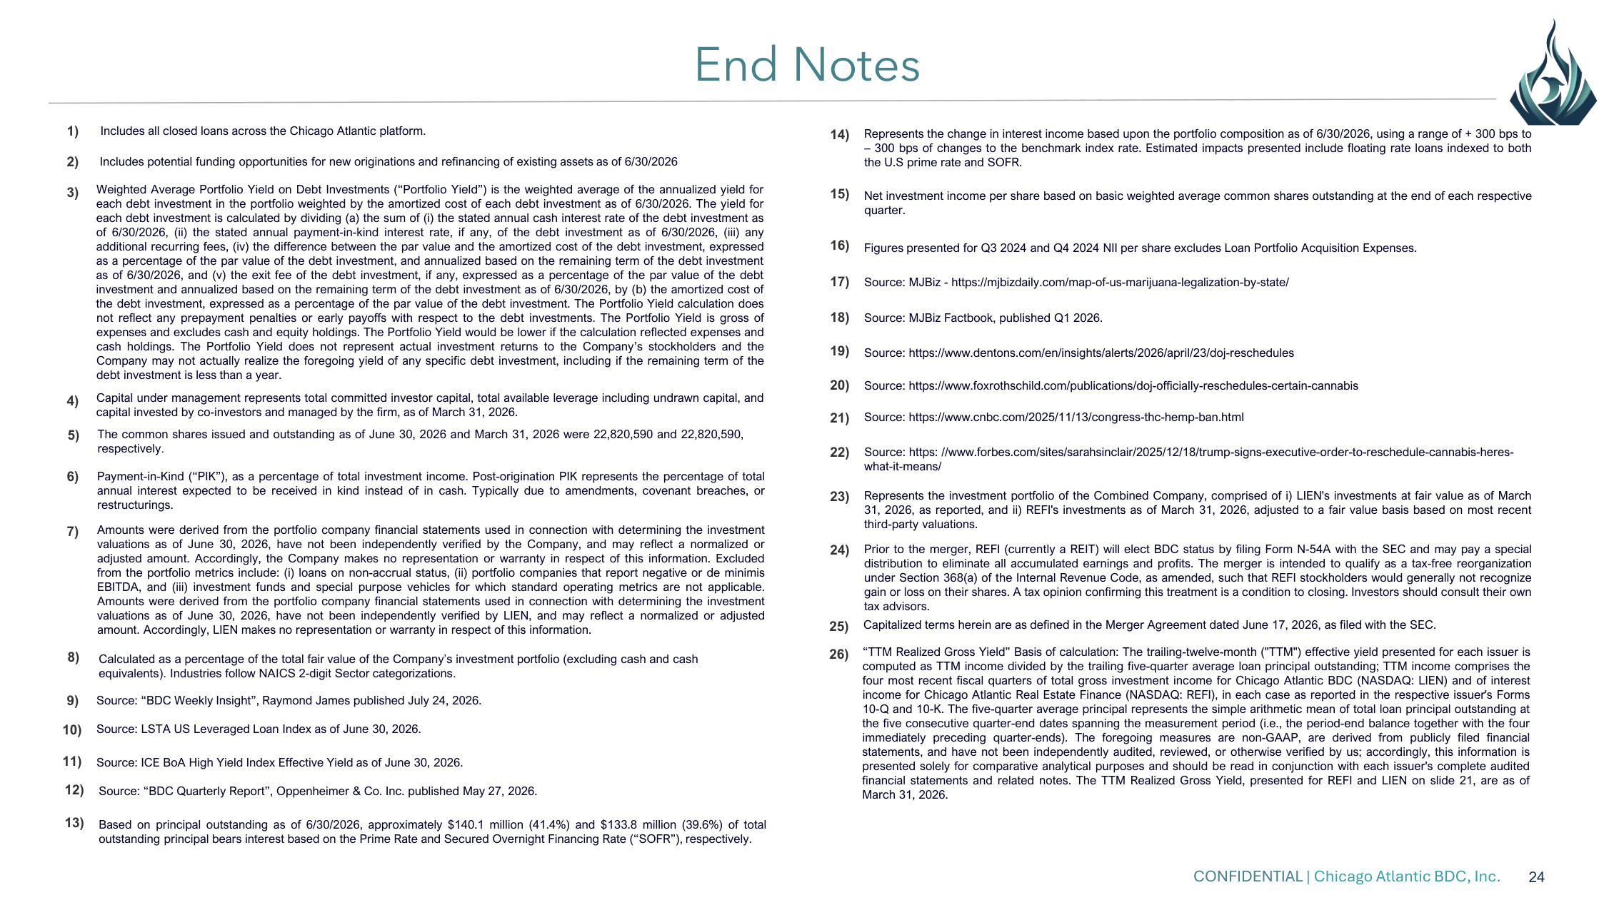
CONFIDENTIAL | Chicago Atlantic BDC, Inc. 24 End Notes 1) Includes all closed loans across the Chicago Atlantic platform. 2) Includes potential funding opportunities for new originations and refinancing of existing assets as of 6/30/2026 3) Capital under management represents total committed investor capital, total available leverage including undrawn capital, and capital invested by co-investors and managed by the firm, as of March 31, 2026. 4) Weighted Average Portfolio Yield on Debt Investments ("Portfolio Yield") is the weighted average of the annualized yield for each debt investment in the portfolio weighted by the amortized cost of each debt investment as of 6/30/2026. The yield for each debt investment is calculated by dividing (a) the sum of (i) the stated annual cash interest rate of the debt investment as of 6/30/2026, (ii) the stated annual payment-in-kind interest rate, if any, of the debt investment as of 6/30/2026, (iii) any additional recurring fees, (iv) the difference between the par value and the amortized cost of the debt investment, expressed as a percentage of the par value of the debt investment, and annualized based on the remaining term of the debt investment as of 6/30/2026, and (v) the exit fee of the debt investment, if any, expressed as a percentage of the par value of the debt investment and annualized based on the remaining term of the debt investment as of 6/30/2026, by (b) the amortized cost of the debt investment, expressed as a percentage of the par value of the debt investment. The Portfolio Yield calculation does not reflect any prepayment penalties or early payoffs with respect to the debt investments. The Portfolio Yield is gross of expenses and excludes cash and equity holdings. The Portfolio Yield would be lower if the calculation reflected expenses and cash holdings. The Portfolio Yield does not represent actual investment returns to the Company's stockholders and the Company may not actually realize the foregoing yield of any specific debt investment, including if the remaining term of the debt investment is less than a year. 5) The common shares issued and outstanding as of June 30, 2026 and March 31, 2026 were 22,820,590 and 22,820,590, respectively. 6) Payment-in-Kind ("PIK"), as a percentage of total investment income. Post-origination PIK represents the percentage of total annual interest expected to be received in kind instead of in cash. Typically due to amendments, covenant breaches, or restructurings. 7) Amounts were derived from the portfolio company financial statements used in connection with determining the investment valuations as of June 30, 2026, have not been independently verified by the Company, and may reflect a normalized or adjusted amount. Accordingly, the Company makes no representation or warranty in respect of this information. Excluded from the portfolio metrics include: (i) loans on non-accrual status, (ii) portfolio companies that report negative or de minimis EBITDA, and (iii) investment funds and special purpose vehicles for which standard operating metrics are not applicable. Amounts were derived from the portfolio company financial statements used in connection with determining the investment valuations as of June 30, 2026, have not been independently verified by LIEN, and may reflect a normalized or adjusted amount. Accordingly, LIEN makes no representation or warranty in respect of this information. 8) Calculated as a percentage of the total fair value of the Company's investment portfolio (excluding cash and cash equivalents). Industries follow NAICS 2-digit Sector categorizations. 9) Source: "BDC Weekly Insight", Raymond James published July 24, 2026. 10) Source: LSTA US Leveraged Loan Index as of June 30, 2026. 11) Source: ICE BoA High Yield Index Effective Yield as of June 30, 2026. 13) Based on principal outstanding as of 6/30/2026, approximately $140.1 million (41.4%) and $133.8 million (39.6%) of total outstanding principal bears interest based on the Prime Rate and Secured Overnight Financing Rate ("SOFR"), respectively. 14) Represents the change in interest income based upon the portfolio composition as of 6/30/2026, using a range of + 300 bps to – 300 bps of changes to the benchmark index rate. Estimated impacts presented include floating rate loans indexed to both the U.S prime rate and SOFR. 15) Net investment income per share based on basic weighted average common shares outstanding at the end of each respective quarter. 16) Figures presented for Q3 2024 and Q4 2024 NII per share excludes Loan Portfolio Acquisition Expenses. 17) Source: MJBiz - https://mjbizdaily.com/map-of-us-marijuana-legalization-by-state/ 18) Source: MJBiz Factbook, published Q1 2026. 19) Source: https://www.dentons.com/en/insights/alerts/2026/april/23/doj-reschedules 20) Source: https://www.foxrothschild.com/publications/doj-officially-reschedules-certain-cannabis 21) Source: https://www.cnbc.com/2025/11/13/congress-thc-hemp-ban.html 22) 23) Represents the investment portfolio of the Combined Company, comprised of i) LIEN's investments at fair value as of March 31, 2026, as reported, and ii) REFI's investments as of March 31, 2026, adjusted to a fair value basis based on most recent third-party valuations. 12) Source: "BDC Quarterly Report", Oppenheimer & Co. Inc. published May 27, 2026. 24) Prior to the merger, REFI (currently a REIT) will elect BDC status by filing Form N-54A with the SEC and may pay a special distribution to eliminate all accumulated earnings and profits. The merger is intended to qualify as a tax-free reorganization under Section 368(a) of the Internal Revenue Code, as amended, such that REFI stockholders would generally not recognize gain or loss on their shares. A tax opinion confirming this treatment is a condition to closing. Investors should consult their own tax advisors. 25) Capitalized terms herein are as defined in the Merger Agreement dated June 17, 2026, as filed with the SEC. Source: https: //www.forbes.com/sites/sarahsinclair/2025/12/18/trump-signs-executive-order-to-reschedule-cannabis-heres- what-it-means/ 26) "TTM Realized Gross Yield" Basis of calculation: The trailing-twelve-month ("TTM") effective yield presented for each issuer is computed as TTM income divided by the trailing five-quarter average loan principal outstanding; TTM income comprises the four most recent fiscal quarters of total gross investment income for Chicago Atlantic BDC (NASDAQ: LIEN) and of interest income for Chicago Atlantic Real Estate Finance (NASDAQ: REFI), in each case as reported in the respective issuer's Forms 10-Q and 10-K. The five-quarter average principal represents the simple arithmetic mean of total loan principal outstanding at the five consecutive quarter-end dates spanning the measurement period (i.e., the period-end balance together with the four immediately preceding quarter-ends). The foregoing measures are non-GAAP, are derived from publicly filed financial statements, and have not been independently audited, reviewed, or otherwise verified by us; accordingly, this information is presented solely for comparative analytical purposes and should be read in conjunction with each issuer's complete audited financial statements and related notes. The TTM Realized Gross Yield, presented for REFI and LIEN on slide 21, are as of March 31, 2026.

